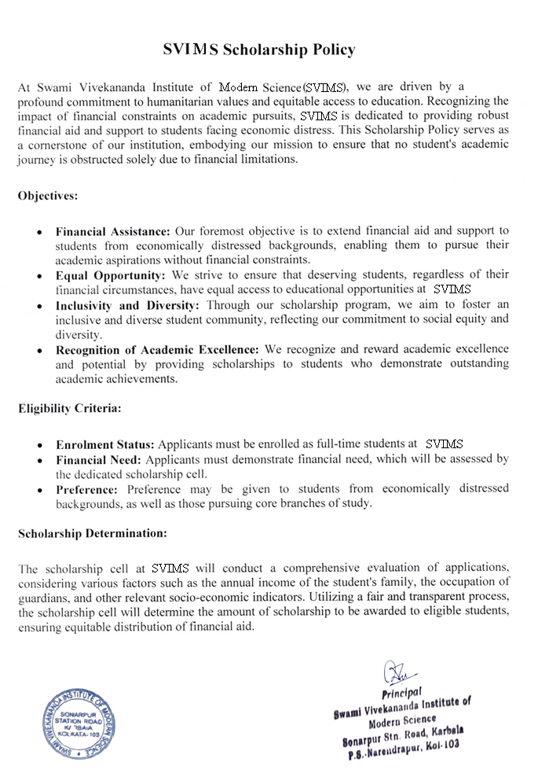



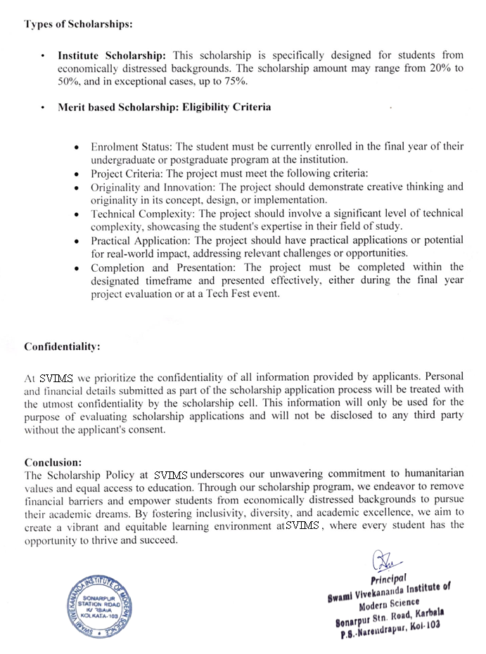



**SVIMs Institute Merit Cum**

**Means Scholarship Scheme**

Swami Vivekananda Institute of Modern Science lays strong emphasis on humanitarian values.

One of the Prime motto of the institute is to provide financial aid/support to the students of economically distressed background so that the academic career of students do not come to an abrupt end due to financial problems only.

The college has a dedicated scholarship cell to determine the amount of scholarship to be given to the eligible students based on the annual income of family, occupation of guardian etc.

Based on the findings and also as a general best practice motive students of mainly core branches are provided with “Institute Scholarship” ranging from 20% to 50 % and in some special cases upto 75%.

