

**Ref No- SVIMS/BBA/2018-19/Add-on/01 Date: 09/07/2018**

**NOTICE**

The Department of Business Administration hereby notifies all students that a 30-hour add-on course on the Power of Advertisement is presently being offered. The Power of Advertisements will be the primary focus of the five-day add-on course, which is scheduled to take place from July 16th to July 20th,2018.   
The course pamphlet contains information regarding the course objectives, course outcomes, and other pertinent details. In this regard, it is mandatory for all students to enrol in this accredited course.

Course Name: Power of Advertisements.

Mode of Class: Offline

Time of the Course: 30 Hrs,

Date: 16/07/2018- 20/07/2018

Timing: 10:30 AM to 1:30 PM and 2:00 PM to 5 PM

Venue: SVIMS Campus

For any query, contact the course coordinator mentioned in the course flyer.

By Order,





Prof. Gargi Gupta

Vice Principal

SVIMS

**Name of the course: 30-hour value-added course on Power of Advertisement**

**Stream**- BBA

DATE: 16/07/2018- 20/07/2018

**COURSE OBJECTIVES:**

CO 1. To provide students with a solid understanding of the fundamental principles that drive effective advertising strategies.

CO 2. To cultivate students' abilities in copywriting, content creation, and storytelling specifically tailored for marketing purposes.

CO 3. To equip students with practical knowledge by exploring various advertising techniques, media planning

|  |  |  |  |  |  |  |  |  |  |  |  |  |
| --- | --- | --- | --- | --- | --- | --- | --- | --- | --- | --- | --- | --- |
| CO/PO | PO1 | PO2 | PO3 | PO4 | PO5 | PO6 | PO7 | PO8 | PO9 | PO10 | PO11 | PO12 |
| CO1. | 0 | 0 | 0 | 0 | 0 | 2 | 0 | 3 | 2 | 3 | 0 | 1 |
| CO2. | 0 | 0 | 1 | 0 | 0 | 1 | 1 | 1 | 2 | 3 | 1 | 1 |
| CO3. | 0 | 1 | 1 | 2 | 0 | 1 | 1 | 2 | 1 | 3 | 0 | 1 |

**Course Report: The Power of Advertisement:**

The Bachelor of Business Administration (BBA) department meticulously orchestrated a 30-hour add-on course entitled "***The Power of Advertisement***" from July 16th to July 20th, 2018. This course was designed to provide students with an exhaustive comprehension of advertising principles and their pragmatic application within the commercial realm. The initiative sought to amalgamate theoretical erudition with practical acumen, thereby equipping our students with the indispensable skills requisite for excelling in the advertising and marketing domains.

The primary objectives of the course were multifaceted. It aimed to impart a profound understanding of advertising concepts and strategies, augment creative cognition and problem-solving prowess, and furnish practical insights into the genesis and management of advertising campaigns. Moreover, it sought to inculcate an awareness of the ethical considerations inherent in advertising and to develop competencies in leveraging contemporary advertising tools and technologies. Through these objectives, the course endeavoured to prepare students for dynamic and influential roles within the perpetually evolving advertising industry.

The pedagogical approach adopted throughout the five-day course was diverse and robust, ensuring an engaging and efficacious learning experience. The course comprised didactic lectures and presentations delivered by our esteemed faculty and industry luminaries, which provided both foundational knowledge and contemporary insights. Additionally, the curriculum incorporated case studies, group discussions, workshops, and practical sessions, enabling students to apply theoretical constructs to real-world scenarios. Guest lectures by industry professionals further enriched the educational experience, offering students a glimpse into cutting-edge trends and practices within the advertising sphere.

We implemented a comprehensive evaluation system to rigorously assess the students' grasp of the course material and their ability to apply it. This encompassed continuous assessments through quizzes and assignments, project work entailing the creation of advertising campaigns, a culminating written examination, and presentations wherein students exhibited their projects and received constructive critique. These assessments ensured that students not only assimilated the theoretical aspects of advertising but also acquired hands-on experience in campaign design and management.

The course achieved its multifarious objectives with resounding success. The students' feedback was overwhelmingly positive, underscoring the course's profound impact on their comprehension of advertising concepts and strategies. The projects submitted by the students evidenced their enhanced creative and analytical skills and heightened awareness of the ethical considerations in advertising. Furthermore, the practical experience garnered through this course has substantially fortified our students' preparedness for illustrious careers in advertising, marketing, and allied fields.

The 30-hour add-on course on "The Power of Advertisement" constituted a valuable enhancement to our BBA curriculum. It endowed our students with essential knowledge and skills, aligning with the rigorous standards of the National Assessment and Accreditation Council (NAAC). The BBA department remains unwaveringly committed to offering such enriching programs that foster the professional growth of our students and prepare them for the competitive and ever-evolving business landscape.

The success of this course is a testament to our faculty's dedication and the collaborative effort of our students. It highlights the importance of integrating practical, industry-relevant education into our academic programs. As we continue to strive for excellence in education, we recognize that such initiatives are pivotal in shaping the future leaders of the business world. We are confident that the knowledge and skills acquired through this course will serve our students well as they embark on their professional journeys, and we look forward to continuing to provide high-quality educational experiences that meet the evolving needs of the industry and our society.



**Model Questions:**

1. What is the first topic discussed in the 30-hour course on the Power of Advertisement? A) Branding B) Media Mix C) Introduction D) Push and Pull

2. Which session will cover aspects related to creating effective marketing messages? A) Copywriting and Content Writing B) Media Buying and Selling C) Storytelling and Advertising Design D) Ad Workshop

3. What topic is scheduled immediately after lunch? A) The Marketing Concept B) Copywriting and Content Writing C) Media Mix D) Branding

4. Which of these topics focuses on strategies to get products into customer's hands? A) Push and Pull B) Media Mix C) Storytelling D) Introduction

5. During which session will participants learn about purchasing space for advertisements? A) Branding B) Ad Workshop C) Media Buying & Selling D) The Marketing Concept

6. What aspect of advertising does "Storytelling" relate to within this course? A) Design principles B) Narrative techniques C) Sales strategies D) Market research

7. Which session likely discusses building a recognizable company image or product perception? A) Introduction

B) Copywriting

C) Branding

D) Advertising

**Model Answers:**

1. C) Introduction

2. A) Copywriting and Content Writing

3. A) The Marketing Concept

4. A) Push and Pull

5. C) Media Buying & Selling

6. B) Narrative techniques

7. C) Branding



Ref No- SVIMS/BBA/2018-19/Add-on/ 02 Date: 10/08/2018

**NOTICE**

A 30-hour add-on course on the Art of Sales is being offered to all students in the Department of Business Administration. The Art of Sales will be the primary focus of the five-day add-on course, which is scheduled to take place from 20/08/2018 to 24/08/2018.

The course pamphlet contains information regarding the course objectives, course outcomes, and other pertinent details. In this regard, it is mandatory for all students to enrol in this accredited course.

Course Name: Art of Sales.

Mode of Class: Offline

Time of the Course: 30 Hrs,

Date: 23/07/2018 – 30/07/2018

Timing: 10:30 AM to 1:30 PM and 2:00 PM to 5PM

Venue: SVIMS Campus

For any query, contact the course coordinator mentioned in the course flyer.

By Order,



Prof. Gargi Gupta

Vice Principal

SVIMS

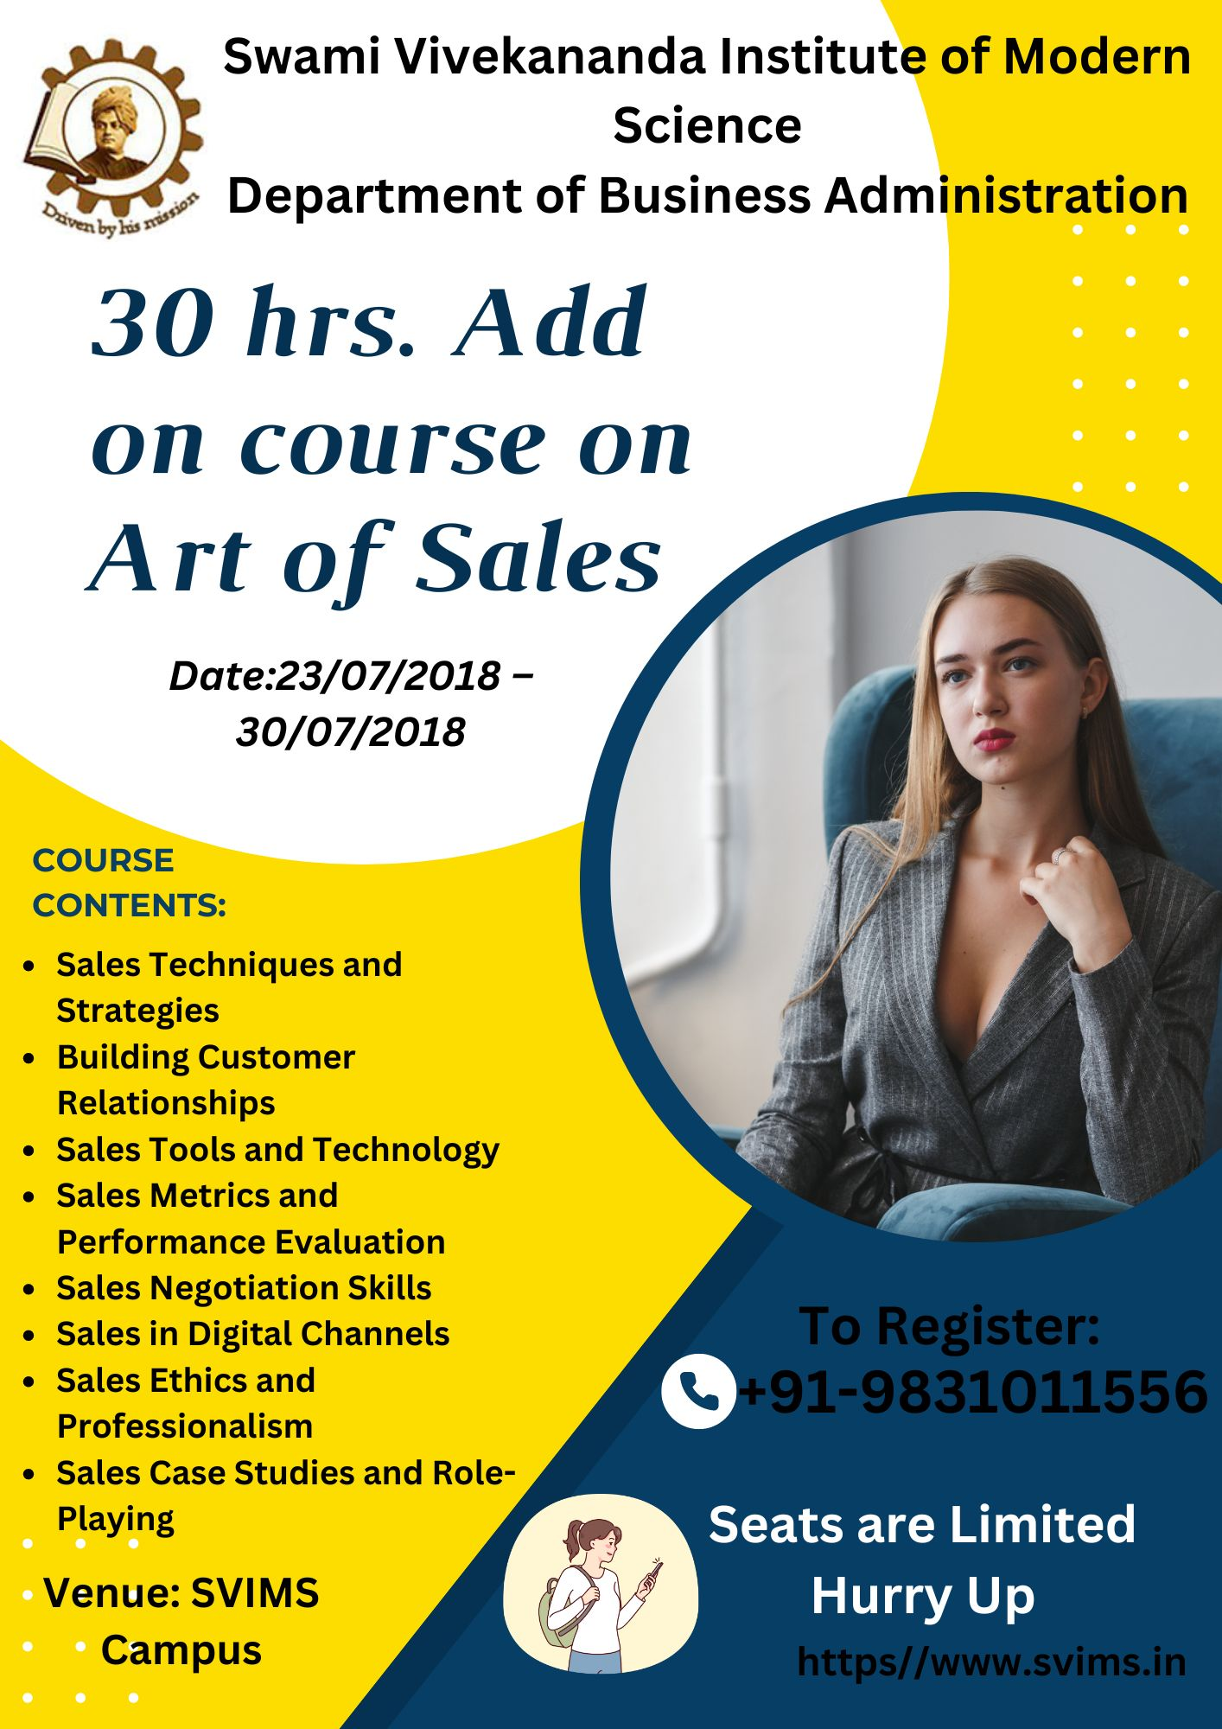

**Name of the course: 30-hour value-added course on Art of Sales**

**Stream**- BBA

DATE: 20/08/2018- 24/08/2018

**COURSE OBJECTIVES:**

CO1: Understand the sales process and its stages.

CO2: Apply effective sales techniques to engage potential customers.

CO3: Develop strong customer relationships and enhance customer satisfaction.

**Programme outcome:**

|  |  |  |  |  |  |  |  |  |  |  |  |  |
| --- | --- | --- | --- | --- | --- | --- | --- | --- | --- | --- | --- | --- |
| CO/PO | PO1 | PO2 | PO3 | PO4 | PO5 | PO6 | PO7 | PO8 | PO9 | PO10 | PO11 | PO12 |
| CO1. | 0 | 0 | 0 | 0 | 0 | 3 | 0 | 2 | 2 | 3 | 0 | 1 |
| CO2. | 0 | 0 | 1 | 0 | 0 | 1 | 1 | 1 | 2 | 3 | 1 | 1 |
| CO3. | 0 | 1 | 2 | 1 | 0 | 1 | 3 | 2 | 1 | 1 | 0 | 1 |

**Course Report on 'The Art of Sales:**

The BBA department orchestrated an intensive 30-hour add-on course titled 'The Art of Sales' from 20th August 2018 to 24th August 2018. This meticulously curated program aimed to endow students with indispensable sales acumen and proficiency, pivotal for excelling in the contemporary business milieu. The curriculum encompassed an array of topics, spanning fundamental to advanced sales concepts, thereby ensuring a comprehensive educational experience for the participants.

The course was initiated with an 'Introduction to Sales', which provided an essential grounding in sales principles and the evolving paradigms within the sales domain. This introductory segment established the foundational knowledge for comprehending the subsequent intricate topics.

In 'Sales Techniques and Strategies', participants were inculcated with a myriad of efficacious sales methodologies, including consultative selling, solution selling, and strategic selling. This module accentuated the necessity of customizing sales tactics to align with diverse customer exigencies and contexts.

The significance of 'Building Customer Relationships' was a cornerstone of the course, elucidating strategies for cultivating and sustaining robust, long-term client relationships. This entailed comprehending customer needs, delivering unparalleled service, and engendering trust.

The segment on 'Sales Tools and Technology' acquainted participants with contemporary sales instruments such as Customer Relationship Management (CRM) systems and sales automation software, demonstrating how technological advancements can streamline sales operations and augment productivity.

Mastering' Sales Metrics and Performance Evaluation' was imperative for students to learn the quantification and analysis of sales efficacy. This module elucidated key performance indicators (KPIs) and methodologies for monitoring sales success and identifying areas necessitating enhancement.

'Sales Psychology and Persuasion Techniques' explored the psychological underpinnings of sales, instructing students on effectively influencing and persuading clients. This encompassed examining buyer behaviour, motivational stimuli, and persuasive communication strategies.

The art of ‘Sales Negotiation Skills’ was another critical facet, wherein students honed their capabilities in negotiating agreements, addressing objections, and consummating sales transactions efficaciously. Role-playing exercises afforded hands-on experience in realistic sales scenarios.

Given the burgeoning significance of digital platforms, ‘Sales in Digital Channels’ addressed strategies for exploiting online channels to reach and engage clientele. This included social media marketing, email campaigns, and e-commerce strategies.

The module on Sales Ethics and Professionalism’ underscored the paramount importance of ethical conduct in sales, covering topics such as honesty, integrity, and ethical decision-making across diverse sales situations.

Lastly, ‘Sales Case Studies and Role-Playing’ provided practical, interactive learning opportunities, enabling students to apply theoretical knowledge to real-world sales scenarios, thereby enhancing their problem-solving and critical-thinking aptitudes.

In summation, this add-on course proffered by the BBA department was instrumental in equipping students with the essential skills and knowledge to excel in sales vocations, fostering both personal and professional development.



**NOTICE**

**Ref No- SVIMS/BBA/2019-20/Add-on/03 Date: 18.03.2019**

A 30-hour add-on course on Economics for Managers is being offered to all students in the Department of Business Administration. The add-on course, which will be conducted over the course of five days from March 25, 2019, to March 29, 2019, will concentrate on Economics for Managers.

The course pamphlet contains information regarding the course objectives, course outcomes, and other pertinent details. In this regard, it is mandatory for all students to enrol in this accredited course.

Course Name: Economics for Managers.

Mode of Class: Online

Time of the Course: 30 Hrs,

Date: 25/03/2019- 29/03/2019

Timing: 10:30 AM to 1:30 PM and 2:00 PM to 5 PM

Venue: SVIMS Campus

For any query, contact the course coordinator mentioned in the course flyer.

By Order,



Prof. Gargi Gupta

Vice Principal

SVIMS

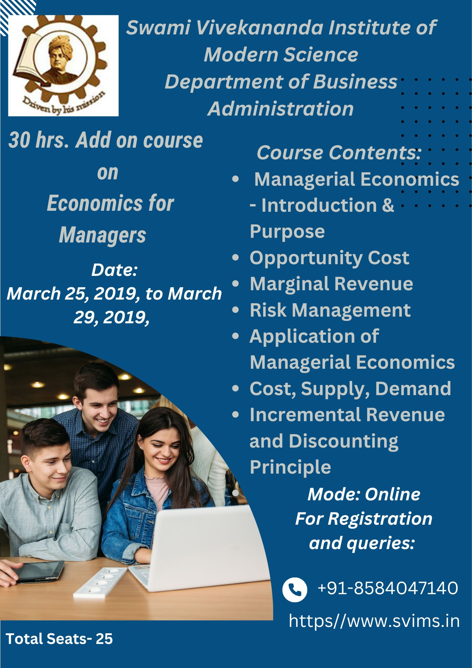

**Course Report: Economics for Managers Date: 20/08/2018 to 24/08/2018**

The BBA department successfully conducted a 30-hour add-on course titled 'Economics for Managers' from 20th August to 24th August 2018. This course was meticulously designed to equip students with a profound understanding of managerial economics, fostering an analytical mindset essential for making informed business decisions. The curriculum was structured to cover fundamental economic principles and their direct applications in the managerial context, ensuring a comprehensive learning experience.

**Course Structure**

The course was divided into ten sessions, each lasting three hours, spread over five days. The detailed schedule is as follows:

* *Day 1: Managerial Economics - Introduction & Purpose*

The inaugural session provided an in-depth introduction to managerial economics, elucidating its purpose and significance in business. This foundational session set the stage for understanding economics's strategic role in managerial decision-making processes.

* *Day 2: Opportunity Cost & Marginal Revenue*

The pre-lunch session focused on the concept of opportunity cost, emphasizing its criticality in resource allocation and strategic planning. Post-lunch, the discussion transitioned to marginal revenue, dissecting its implications for maximizing profitability and enhancing operational efficiency.

* *Day 3: Risk Management & Application of Managerial Economics*

Risk management was the focal point of the pre-lunch session, highlighting methods to identify, assess, and mitigate risks in a business environment. The post-lunch session delved into practical applications of managerial economics, demonstrating how theoretical principles are translated into real-world business strategies.

* *Day 4: Cost, Supply, Demand & Incremental Revenue and Discounting Principle*

The fourth day commenced with an exploration of cost structures, supply and demand dynamics, and their interconnectedness. The afternoon session introduced the incremental revenue and discounting principles, underscoring their relevance in long-term financial planning and investment decisions.

* *Day 5: Time Impact on Managerial Decision - Short Term and Long Term & Market Regulation and* *Government Policies*

The final day addressed the temporal dimensions of managerial decisions, comparing short-term and long-term perspectives. Subsequently, the course concluded with a discussion on market regulation and government policies, evaluating their impact on business operations and strategic planning.

* *Feedback and Valedictory Session*

The course culminated with a feedback and valedictory session, where participants shared their insights and experiences. This interactive segment provided valuable feedback for future improvements and acknowledged the participants' dedication and enthusiasm.

**Conclusion**

The 'Economics for Managers' course proved to be an invaluable addition to the academic offerings of the BBA department. By integrating economic theory with practical managerial applications, the course significantly enhanced the analytical and decision-making skills of the students. The rigorous curriculum, combined with interactive sessions, ensured a holistic understanding of managerial economics. The knowledge gained through this course is expected to empower students to navigate complex business environments with confidence and acumen, thereby contributing to their overall professional growth and success.

**Name of the course: 30-hour value-added course on “Economics for Managers”**

**Stream**- BBA

DATE: 25/03/2019- 29/03/2019

**COURSE OBJECTIVES:**

CO 1. To apply fundamental economic principles to real-world business challenges.

CO 2. To understand customer demand, supplier costs, pricing, and output decisions.

CO 3. To [develop the beginnings of a competitive strategy that leads to a growing and profitable business](https://info.online.hbs.edu/hubfs/Economics%20for%20Managers/Syllabus_Economics_for_Managers.pdf).

**Programme Outcome:**

|  |  |  |  |  |  |  |  |  |  |  |  |  |
| --- | --- | --- | --- | --- | --- | --- | --- | --- | --- | --- | --- | --- |
| CO/PO | PO1 | PO2 | PO3 | PO4 | PO5 | PO6 | PO7 | PO8 | PO9 | PO10 | PO11 | PO12 |
| CO1. | 0 | 0 | 0 | 0 | 0 | 2 | 3 | 3 | 2 | 0 | 0 | 1 |
| CO2. | 0 | 0 | 1 | 0 | 1 | 0 | 1 | 1 | 2 | 3 | 1 | 1 |
| CO3. | 1 | 0 | 1 | 2 | 0 | 1 | 2 | 1 | 1 | 3 | 0 | 1 |



**Ref No- SVIMS/BBA(UG)/2019-20/Add-on/04 Date: 30/05/2019**

**NOTICE**

A 30-hour add-on course on the "Understanding Marketing Environment" is hereby announced to all students in the Department of Business Administration. The five-day add-on course, which is scheduled to take place from 06/08/2019 to 10/08/2019, will concentrate on comprehending the marketing environment.

The course pamphlet contains information regarding the course objectives, course outcomes, and other pertinent details. In this respect, it is mandatory for all students to enrol in this accredited course.

Course Name: Understanding Marketing Environment.

Mode of Class: Online

Time of the Course: 30 Hrs,

Date: 06/08/2019- 10/08/2019

Timing: 10:30 AM to 1:30 PM and 2:00 PM to 5 PM

For any query, contact the course coordinator mentioned in the course flyer.

By Order,



Prof. Gargi Gupta

Vice Principal

SVIMS

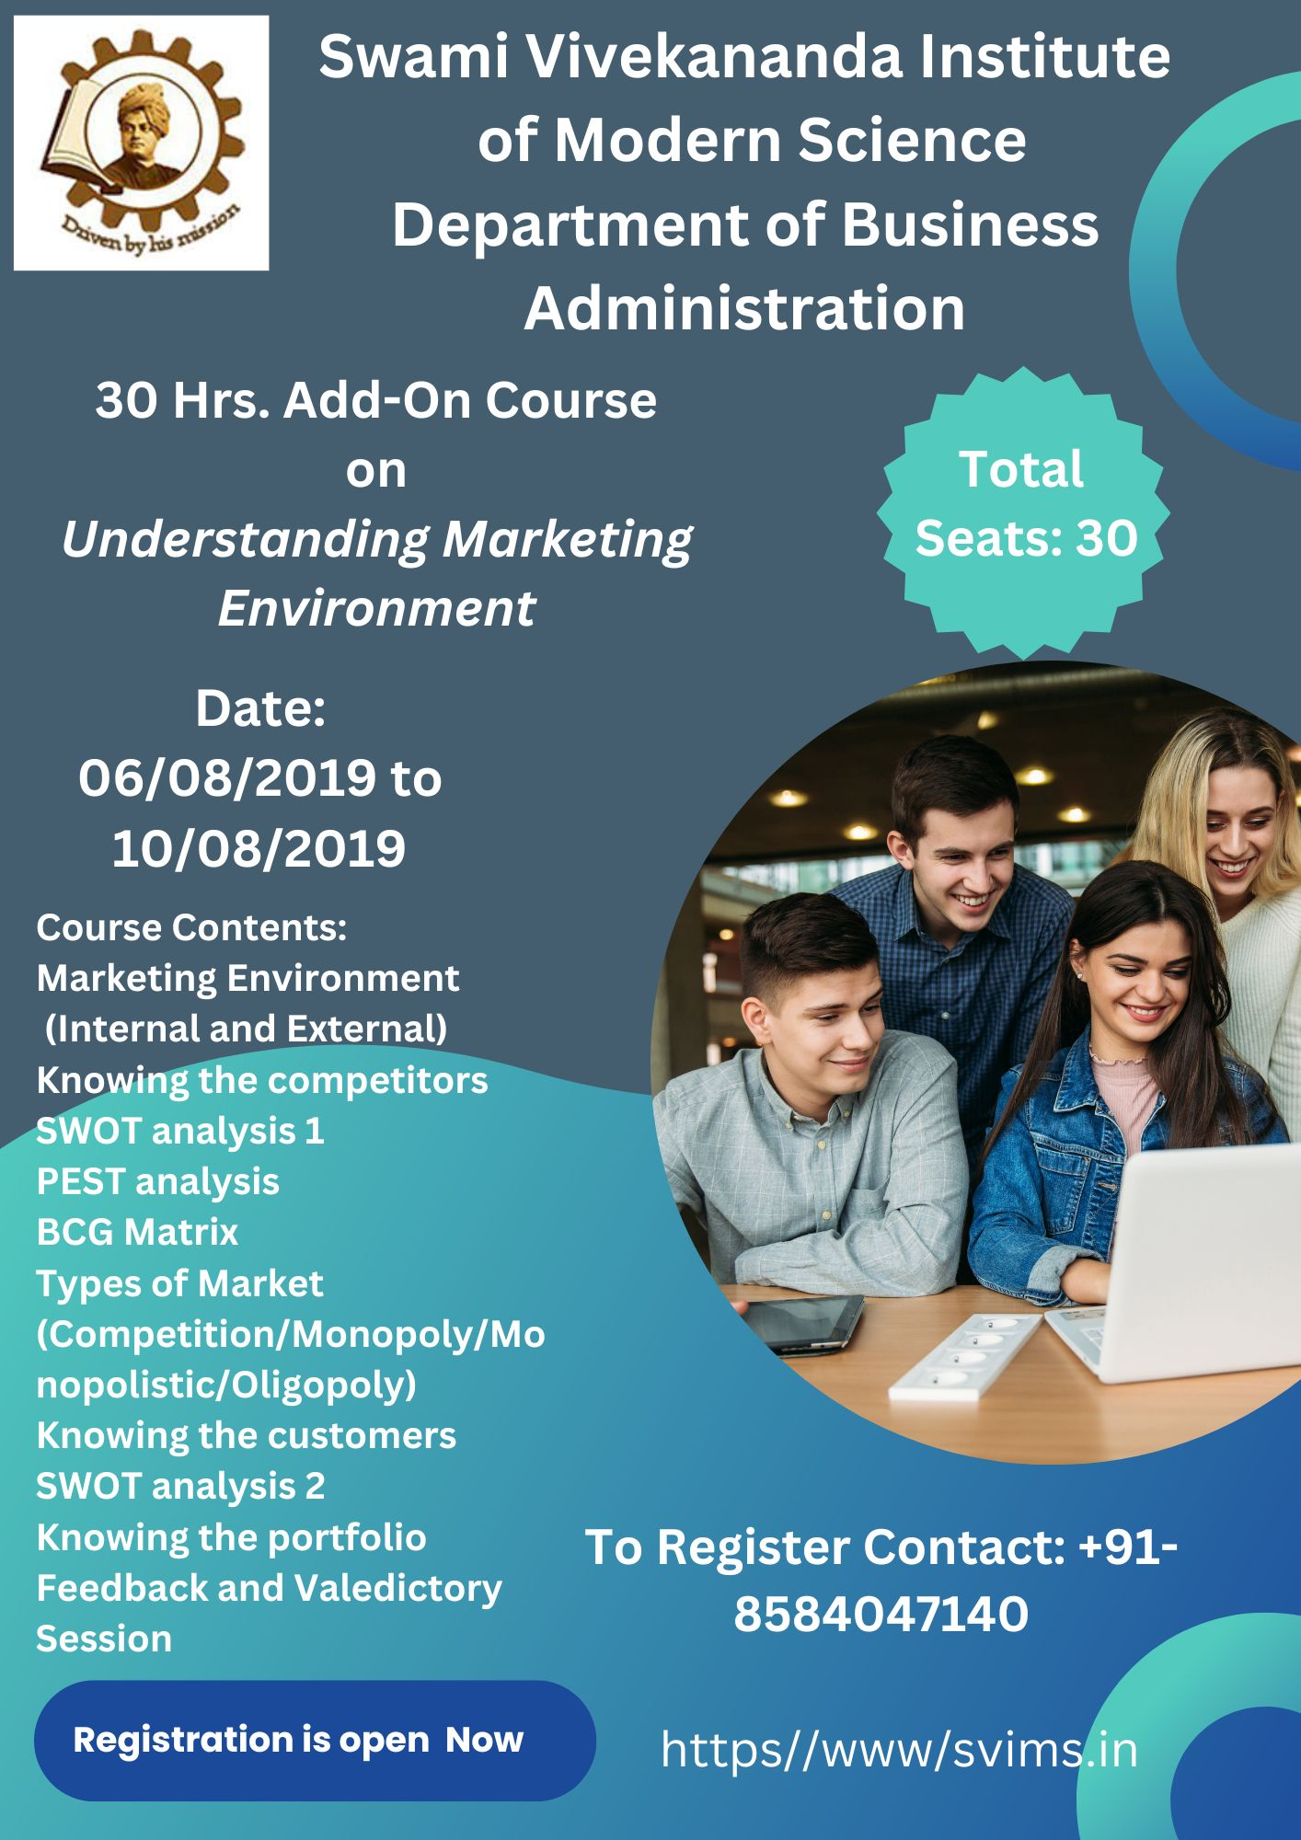

**Name of the course: 30-hour value-added course on “Understanding Marketing Environment”**

**Stream**- BBA

DATE: 06/08/2019- 10/08/2019

**COURSE OBJECTIVES:**

CO 1. Students will grasp the fundamental concepts of marketing, including its purpose, role, and impact on organizations and society.

CO 2. Participants will learn about the primary marketing activities, emphasizing the customer-centric approach and the marketing mix (product, price, place, and promotion).

CO 3. Students will understand market segmentation and targeting, enabling them to identify and prioritize customer segments for effective marketing strategies.

**Programme Outcome:**

|  |  |  |  |  |  |  |  |  |  |  |  |  |
| --- | --- | --- | --- | --- | --- | --- | --- | --- | --- | --- | --- | --- |
| CO/PO | PO1 | PO2 | PO3 | PO4 | PO5 | PO6 | PO7 | PO8 | PO9 | PO10 | PO11 | PO12 |
| CO1. | 0 | 0 | 0 | 0 | 0 | 2 | 3 | 3 | 2 | 0 | 0 | 1 |
| CO2. | 0 | 0 | 1 | 0 | 1 | 0 | 1 | 1 | 2 | 3 | 1 | 1 |
| CO3. | 1 | 0 | 1 | 2 | 0 | 1 | 2 | 1 | 1 | 3 | 0 | 1 |

**Report on the 30-Hour Value-Added Course on Understanding Marketing Environment**

**Organized by:** The BBA Department  
**Duration:** 20/08/2018 to 24/08/2018  
**Total Hours:** 30 Hours

**Introduction**

In an era marked by rapid globalization and technological advancements, understanding the nuances of the marketing environment is imperative for budding business professionals. The BBA department's meticulously designed 30-hour value-added course on "Understanding Marketing Environment" serves as a beacon of knowledge and practical wisdom aimed at equipping students with the analytical prowess and strategic insight necessary for thriving in today's dynamic market landscape. This report elucidates the course's structure, content, and impact, showcasing how it prepares students for future career opportunities and professional excellence.

**Course Structure and Content**

The course was carefully segmented into ten modules, each spanning three hours, and thoughtfully divided into pre-lunch and post-lunch sessions to maintain high levels of engagement and retention among participants.

**Pre-Lunch Sessions:**

1. **Marketing Environment (Internal and External):** The journey commenced with an in-depth exploration of the marketing environment, delineating the internal and external factors that influence marketing strategies. This session underscored the significance of comprehending both micro and macro-environmental elements, setting a robust foundation for strategic marketing decisions. Students were introduced to the intricate interplay between internal factors like organizational culture, resources, and capabilities and external factors such as market trends, economic conditions, and regulatory frameworks.
2. **Knowing the Competitors:** The next module delved into competitor analysis, a critical component of strategic planning. Participants learned to systematically identify and evaluate competitors, gaining insights into their strengths, weaknesses, opportunities, and threats. This session emphasized the importance of staying vigilant and proactive in a competitive marketplace, equipping students with the tools to anticipate competitor moves and develop counter-strategies.
3. **SWOT Analysis 1:** In this initial session on SWOT analysis, students were introduced to the fundamental framework for assessing an organization's internal strengths and weaknesses alongside external opportunities and threats. Through interactive exercises and real-world case studies, participants practised conducting SWOT analyses, honing their ability to derive actionable insights and formulate strategic recommendations.
4. **PEST Analysis:** This module focused on the PEST analysis framework, examining the political, economic, social, and technological factors that shape the marketing environment. Students learned to apply PEST analysis to anticipate and respond to external changes, enhancing their strategic foresight and adaptability. The session highlighted the importance of staying attuned to macro-environmental trends and their potential impact on business operations.
5. **BCG Matrix:** The Boston Consulting Group (BCG) Matrix was introduced as a strategic tool for portfolio management. Participants explored how to categorize products or business units based on their market growth rate and relative market share, using this analysis to allocate resources and prioritize investments. Through practical applications, students gained a deeper understanding of managing a diversified portfolio and optimizing business performance.

**Post-Lunch Sessions:**

1. **Types of Market (Competition/Monopoly/Monopolistic/Oligopoly):** This module provided a comprehensive overview of various market structures, including competition, monopoly, monopolistic competition, and oligopoly. Students examined each market type's characteristics and strategic implications, learning how different competitive dynamics influence business strategies and consumer behaviour. The session taught participants to navigate diverse market environments and tailor their approaches accordingly.
2. **Knowing the Customers:** The focus then shifted to customer analysis, an essential aspect of marketing strategy. Participants learned techniques for identifying and understanding customer needs, preferences, and behaviours. This session emphasized the importance of creating customer-centric strategies and building long-term relationships with target audiences. By developing customer personas and segmentation strategies, students were prepared to craft personalized marketing messages and enhance customer satisfaction.
3. **SWOT Analysis 2:** Building on the foundational knowledge from the first SWOT analysis session, this advanced module engaged students in more complex SWOT analysis exercises. Participants developed strategic recommendations based on their analyses, refining their ability to think critically and strategically. This session reinforced the dynamic nature of SWOT analysis, encouraging students to continuously update and refine their strategies in response to evolving circumstances.
4. **Knowing the Portfolio:** This module underscored the importance of portfolio management in achieving strategic alignment and maximizing organizational value. Students learned to evaluate and manage a portfolio of products or services, ensuring alignment with organizational goals and market demands. Through hands-on activities, participants gained insights into balancing risk and reward, optimizing resource allocation, and driving portfolio performance.
5. **Feedback and Valedictory Session:** The course concluded with a feedback session, where participants shared their learning experiences and provided suggestions for future courses. The valedictory session celebrated the participants' efforts and achievements, fostering a sense of accomplishment and motivation. Certificates were awarded, recognizing the commitment and engagement of each participant. This session provided an opportunity for reflection and reinforced the importance of lifelong learning.

**Conclusion**

The "Understanding Marketing Environment" course was a resounding success, providing participants with a robust foundation in marketing analysis and strategy. The structured approach, combining theoretical frameworks with practical applications, ensured a comprehensive learning experience. The feedback received was overwhelmingly positive, highlighting the course's relevance and impact on participants' professional development. This course exemplifies the BBA department's commitment to academic excellence and continuous improvement, significantly contributing to students' skills and knowledge development.

**Impact on Career and Future Opportunities**

This course has proven to be instrumental in shaping the career trajectories of our students. Equipping them with critical analytical tools and strategic insights prepares them for a wide array of career opportunities in marketing, strategic planning, and business development. The practical skills and theoretical knowledge gained through this course enable our graduates to excel in competitive job markets, pursue advanced studies, and assume leadership roles in their respective fields.



**Ref No- SVIMS/BBA/2020-21/Add-On/05 Date: 10/02/2020**

**NOTICE**

All the students of the Department of Business Administration are hereby informed that a 30-hour add-on course on the Power of Human Capital is being offered. The add-on course is scheduled to be held on 15/02/2020, 16/02/2020, 22/02/2020, 23/02/2020, and 29/02/ 2020, spanning five days, focusing on the Power of Human Capital.

The course objectives, course outcomes, and other details are mentioned in the course flyer. In this regard, all students are required to attend this certified course.

Course Name: Power of Human Capital.

Mode of Class: Online

Time of the Course: 30 Hrs.

Date: 15th February 2020- 29th February 2020

Timing: 10:30 AM to 1:30 PM and 2:00 PM to 5 PM

For any query, contact the course coordinator mentioned in the course flyer.

By Order,

Prof. Gargi Gupta

Vice Principal

SVIMS

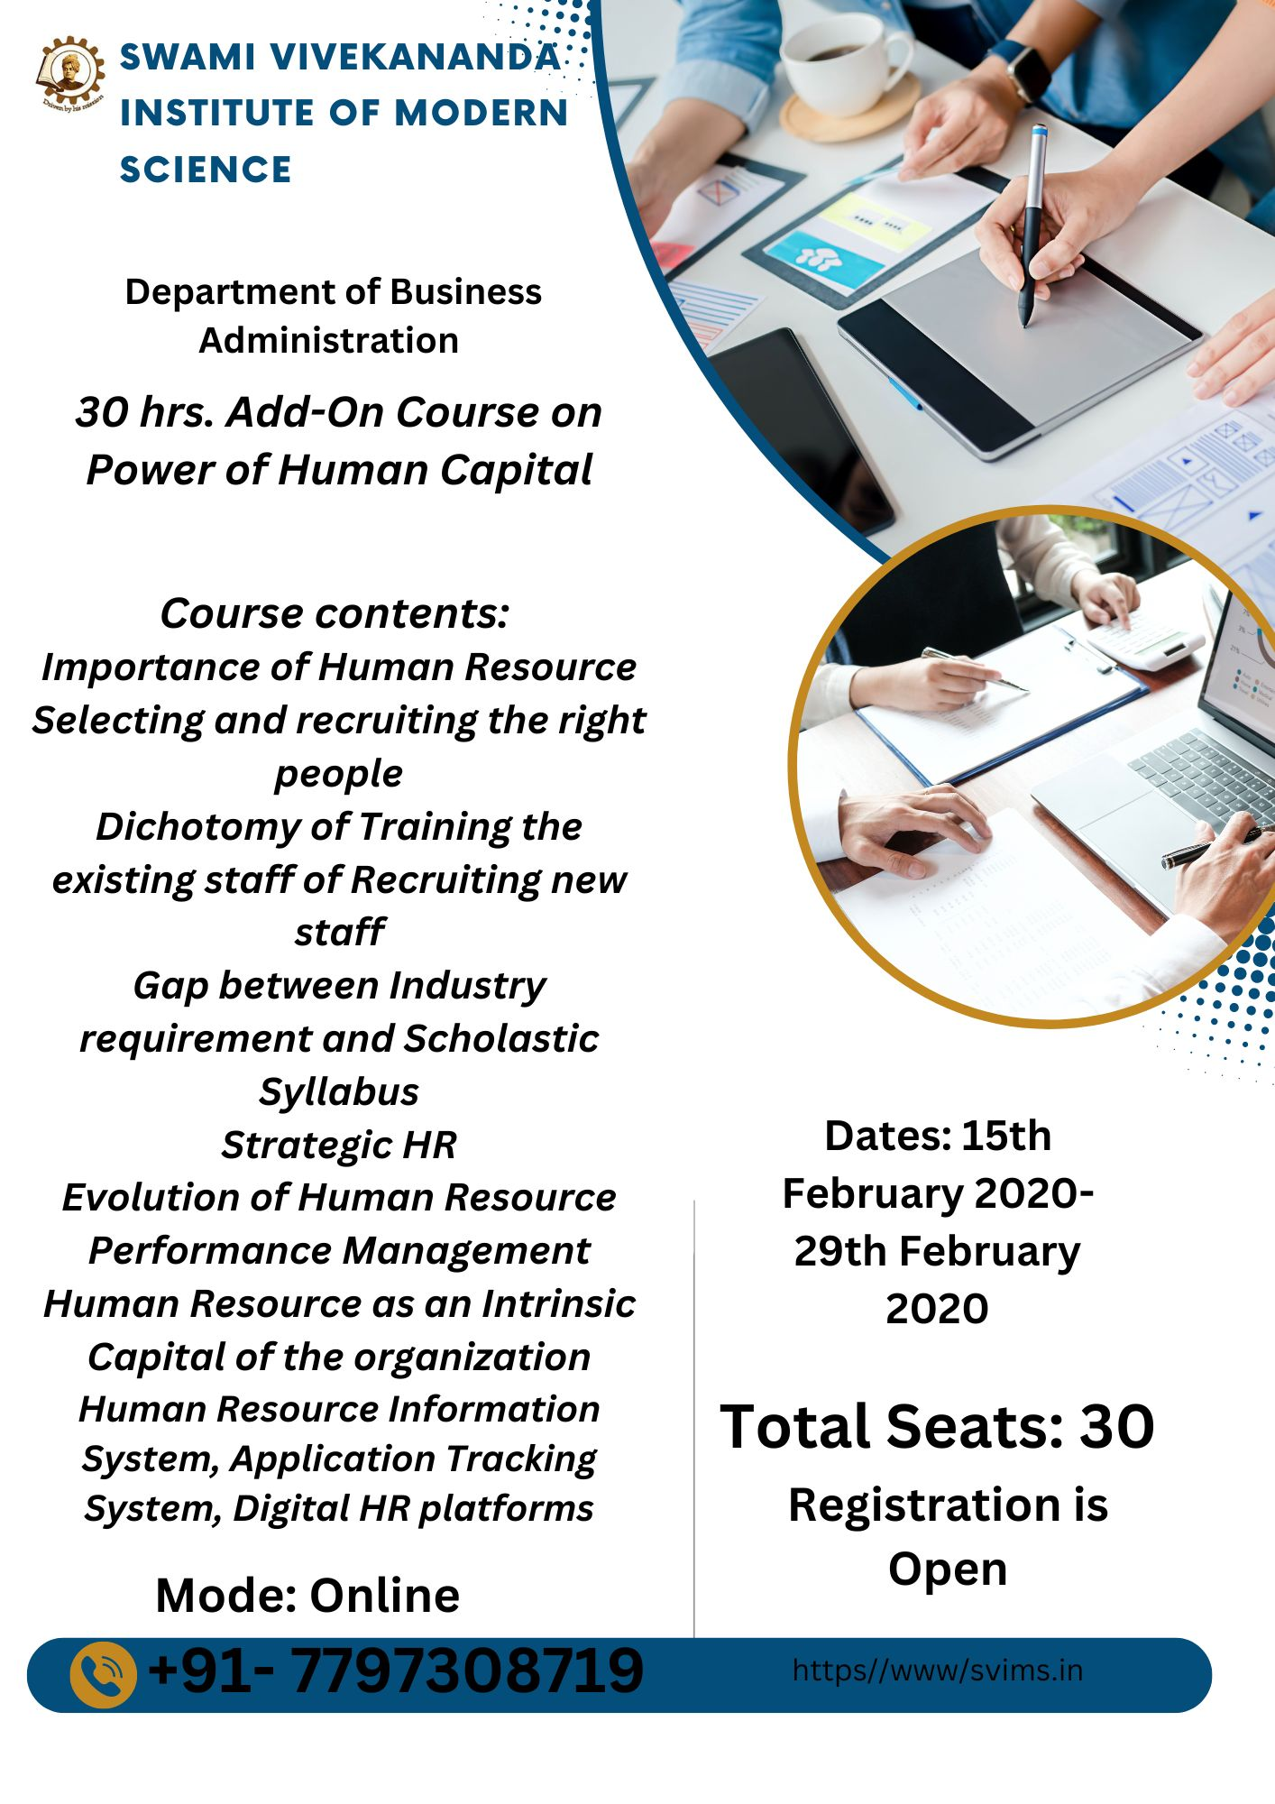

**Name of the course: 30-hour value-added course on Power of Human Capital**

**Stream**- BBA

DATE: 15th February 2020- 29th February 2020

**COURSE OBJECTIVES:**

CO 1. Develop a comprehensive understanding of human capital and its significance in organisational growth and success.

CO 2. Apply strategic human resource management principles to enhance organisational efficiency and employee satisfaction.

CO 3. Design and implement practical training and development programs to improve employee skills and productivity.

**Programme Outcome:**

|  |  |  |  |  |  |  |  |  |  |  |  |  |
| --- | --- | --- | --- | --- | --- | --- | --- | --- | --- | --- | --- | --- |
| CO/PO | PO1 | PO2 | PO3 | PO4 | PO5 | PO6 | PO7 | PO8 | PO9 | PO10 | PO11 | PO12 |
| CO1. | 0 | 0 | 3 | 0 | 0 | 2 | 0 | 3 | 0 | 0 | 2 | 1 |
| CO2. | 0 | 1 | 0 | 0 | 1 | 3 | 1 | 1 | 2 | 0 | 1 | 1 |
| CO3. | 1 | 0 | 1 | 2 | 0 | 1 | 2 | 1 | 1 | 0 | 3 | 1 |

**Name of the course: 30-hour value-added course on the Power of Human Capital**

**Stream**- BBA

DATE: 15th February 2020- 29th February 2020

**COURSE OBJECTIVES:**

CO1: Students will gain insight into the concept of human capital, recognizing its significance in organizational success.

CO2: Students will explore strategies for talent acquisition, development, and retention.

CO3: Students will recognize the value of diversity and learn how to create an inclusive work environment.

**Programme outcome:**

|  |  |  |  |  |  |  |  |  |  |  |  |  |
| --- | --- | --- | --- | --- | --- | --- | --- | --- | --- | --- | --- | --- |
| CO/PO | PO1 | PO2 | PO3 | PO4 | PO5 | PO6 | PO7 | PO8 | PO9 | PO10 | PO11 | PO12 |
| CO1. | 0 | 0 | 0 | 0 | 0 | 3 | 0 | 2 | 2 | 3 | 0 | 1 |
| CO2. | 0 | 0 | 1 | 0 | 0 | 1 | 1 | 1 | 2 | 3 | 1 | 1 |
| CO3. | 0 | 1 | 2 | 1 | 0 | 1 | 3 | 2 | 1 | 1 | 0 | 1 |

**Course Report: Course on the Significance of Human Capital**The 30-hour value-added course on "Power of Human Capital" was created with the aim of equipping students with a deep comprehension of the crucial significance of human resources in the achievement and expansion of a business. This extensive training lasted five rigorous days, with sessions before and after lunch, covering various topics essential to human resource management. The course's objective was to provide students with the necessary theoretical knowledge and practical skills required to flourish in the ever-changing field of human resource management.   
Timetable   
**Day 1: Significance of Human Resource / Development of Human Resource**Prior to lunch, the significance of human resource management will be discussed.   
The seminar began by extensively examining the significance of human resources. Students were acquainted with the notion of human capital and its crucial significance in attaining organizational objectives. The seminar underscored the importance of people as crucial resources, emphasizing how their expertise, understanding, and abilities propel innovation, efficiency, and a competitive edge.   
Afternoon: The Development of Human Resources   
During the afternoon, the attention turned towards the historical development of human resource management. This seminar examined the evolution of HR practices from conventional personnel management to contemporary strategic human resource management. Students were educated on important achievements and fundamental changes that have influenced current HR practices.   
**Day 2** will focus on the process of selecting and recruiting the most suitable individuals for a particular role, as well as performance management.   
Before lunch, the topic will focus on selecting and recruiting the most suitable individuals.   
On the second day, the focus was on the crucial procedures of identifying and hiring the appropriate individuals with the necessary skills and qualifications. Students were acquainted with many recruitment tactics, such as corporate branding, job analysis, and competency-based selection. The lecture offered pragmatic ideas for developing efficient recruitment procedures that are in line with organizational requirements.   
After lunch, we will be discussing performance management.   
The afternoon session centred on performance management systems. Students examined various techniques for evaluating performance, establishing objectives, and providing feedback. The seminar highlighted the significance of ongoing performance enhancement and its influence on employee motivation and the firm's overall success.   
**Day 3:** The Dilemma of Training Current Staff vs Hiring New Staff / Human Resources as Essential Capital   
Pre-Lunch: The Choice Between Training the Current Staff or Hiring New Staff   
On the third day, we started by discussing the contrast between providing training to current employees and seeking out fresh talent through recruitment. Students analyzed the benefits and difficulties associated with both methods, taking into account issues such as expenses, duration, and corporate culture. This session offered an equitable viewpoint on making well-informed human resources decisions.   
After lunch: Human resource as inherent capital.   
During the afternoon session, the course emphasized the importance of human resources as essential capital. This seminar emphasized the immeasurable worth of human capital and its role in creating a lasting competitive advantage. Students were educated on the concepts of intellectual capital, organizational knowledge, and the strategic significance of fostering and keeping talent.   
**Day 4:** Discrepancy between Industry Requirements and Academic Curriculum / Human Resource Information Systems (HRIS), Applicant Tracking Systems (ATS), and Digital Human Resources Platforms   
The pre-lunch session will focus on the disparity between the requirements of the industry and the content covered in the academic syllabus.   
On the fourth day, the main focus was on recognizing and closing the disparity between the needs of the industry and the content taught in academic programs. Students participated in conversations regarding the synchronization of educational curricula with the changing requirements of the corporate realm. The discussion highlighted the significance of partnerships between industry and academics in order to generate graduates who are prepared for employment.   
After lunch, we will be discussing HRIS (Human Resource Information Systems), ATS (Applicant Tracking Systems), and Digital HR Platforms.   
During the afternoon session, students were acquainted with contemporary HR technology such as Human Resource Information Systems (HRIS), Applicant Tracking Systems (ATS), and digital HR platforms. This seminar offered practical experience with these technologies, demonstrating their ability to simplify HR processes, increase productivity, and enhance decision-making.   
**Day 5** will focus on Strategic HR, including discussions on feedback and a valedictory session.   
Before lunch: Strategic Human Resources   
The last day of the seminar was focused on strategic human resources management. Students were educated on the incorporation of HR strategies with company objectives, workforce planning, talent management, and succession planning. The discussion emphasized the importance of HR leaders in promoting corporate performance through strategic initiatives.   
After lunch, there will be a session to provide feedback and a valedictory session.   
The training ended with a session for receiving feedback and delivering a valedictory address. Students were given the chance to contemplate their learning experiences, exchange observations, and offer comments on the course. The valedictory session marked the accomplished conclusion of the course, where participants were presented with certificates.   
Effects and Advantages   
The "Power of Human Capital" course greatly enhanced students' understanding and proficiency in human resource management. The comprehensive program provided students with the necessary skills and knowledge to effectively manage different HR tasks and overcome problems in real-life situations. The course's interactive and pragmatic approach cultivated critical thinking, problem-solving aptitude, and strategic planning proficiency.   
Improved comprehension of human resources   
Students deeply understood the crucial role that human capital plays in achieving organizational success. The workshop highlighted the importance of workers as crucial resources and offered knowledge on HR strategies that improve employee engagement, motivation, and performance.   
Practical skills and technological proficiency are essential abilities that individuals should possess.   
The practical courses on Human Resource Information Systems (HRIS), Applicant Tracking Systems (ATS), and digital Human Resources (HR) platforms provided students with hands-on experience and expertise in using these technologies. These skills are essential in the current era of digital technology when technology plays a critical role in HR administration. Students acquired the skills to utilize these tools in order to optimize HR procedures, enhance productivity, and make informed decisions based on data.   
Strategic Human Resources Management   
The course's emphasis on strategic HR management equipped students with the skills to synchronize HR strategies with organizational objectives. They acquired the skills to create and execute HR strategies that align with corporate goals, stimulate creativity, and cultivate a favourable organizational environment. Having a strategic perspective is crucial for HR professionals who want to make a meaningful impact on the long-term performance of their firm.   
Significance in the industry and job market   
The training improved students' employability by bridging the gap between industrial requirements and academic courses. The focus on industry-specific skills and knowledge guarantees that students are prepared for employment and capable of fulfilling the changing requirements of the business sector. The course also facilitated interactions with industry professionals, so augmenting students' employment chances.   
In conclusion,   
The 30-hour value-added course on "Power of Human Capital" was highly successful, equipping students with a thorough comprehension of human resource management and its strategic significance. The course provided students with practical skills, technological expertise, and a strategic outlook necessary for succeeding in the ever-changing world of HR. The knowledge and abilities acquired from this course will undeniably enhance the students' professional development and positively impact the success of the organizations they will work for.   
As the course coordinator, I take pride in the accomplishments of our students and have full confidence that this course has established a solid groundwork for their future employment in human resource management. I really anticipate observing their ongoing achievements and valuable contributions to the area.



**Ref No- SVIMS/BBA/2020-21/Add-on/06 Date: 02/07/2020**

**NOTICE**

All the students of the Department of Business Administration are hereby informed that a 30-hour add-on course on The Art of Communication is being offered. The add-on course is scheduled to be held from 14/07/2020 to 18/07/2020, spanning five days, focusing on The art of communication.

The course objectives, course outcomes, and other details are mentioned in the course flyer. In this regard, all students are required to attend this certified course.

Course Name: The art of communication.

Mode of Class: Online

Time of the Course: 30 Hrs,

Date: 14/07/2020- 18/7/2020

Timing: 10:30 AM to 1:30 PM and 2:00 PM to 5 PM

For any query, contact the course coordinator mentioned in the course flyer.

By Order,

Prof. Gargi Gupta

Vice Principal

SVIMS



**Name of the course: 30-hour value-added course on “The Art of Communication.”**

**Stream**- BBA

DATE: 14/07/2018- 18/07/2020

**COURSE OBJECTIVES:**

CO 1. To develop a foundational understanding of communication theories, models, and principles.

CO 2. To improve verbal communication skills, including clarity, fluency, and effective expression.

CO 3. To learn active listening skills to engage in meaningful conversations and understand others better.

**Programme Outcome:**

|  |  |  |  |  |  |  |  |  |  |  |  |  |
| --- | --- | --- | --- | --- | --- | --- | --- | --- | --- | --- | --- | --- |
| CO/PO | PO1 | PO2 | PO3 | PO4 | PO5 | PO6 | PO7 | PO8 | PO9 | PO10 | PO11 | PO12 |
| CO1. | 0 | 0 | 0 | 0 | 0 | 2 | 3 | 3 | 2 | 0 | 0 | 1 |
| CO2. | 0 | 0 | 1 | 0 | 1 | 0 | 1 | 1 | 2 | 3 | 1 | 1 |
| CO3. | 1 | 0 | 1 | 2 | 0 | 1 | 2 | 1 | 1 | 3 | 0 | 1 |

**Ref No- SVIMS/BBA(UG)/2021-22/Add-on/07 Date: 12/04/2021**

**NOTICE**

A 30-hour add-on course on ***Digital Marketing- The New Era*** is being offered to all students in the Business Administration Department. The add-on course, which will be conducted over the course of five days from ***April 19, 2021, to April 23, 2021***, will concentrate on Digital Marketing - The New Era.

The course pamphlet contains information regarding the course objectives, course outcomes, and other pertinent details. In this respect, it is mandatory for all students to enrol in this accredited course.

Course Name: ***Digital Marketing - The New Era***.

Mode of Class: Offline

Time of the Course: 30 Hrs,

Date: 19/04/2021- 23/04/2021

Timing: 10:30 AM to 1:30 PM and 2:00 PM to 5 PM

Venue: SVIMS Campus

For any query, contact the course coordinator mentioned in the course flyer.

By Order,



Prof. Gargi Gupta

Vice Principal

SVIMS

**Ref No- SVIMS/BBA(UG)/2021-22/Add-on/08 Date: 16/08/2021**

**NOTICE**

We would like to inform all Department of Business Administration students that a 30-hour add-on course on ***Entrepreneurship and IPR*** is currently being offered. The Entrepreneurship and IPR-focused add-on course is scheduled to take place from August 24, 2021, to August 27, 2021, over five days.

The course pamphlet contains information regarding the course objectives, outcomes, and other pertinent details. Enrolling in this accredited course is mandatory for all students.

Course Name: ***Entrepreneurship and IPR.***

Mode of Class: Offline

Time of the Course: 30 Hrs,

Date: 24/08/2021- 27/08/2021

Timing: 10:30 AM to 1:30 PM and 2:00 PM to 5 PM

Venue: SVIMS Campus

For any query, contact the course coordinator mentioned in the course flyer.

By Order,



Prof. Gargi Gupta

Vice Principal

SVIMS

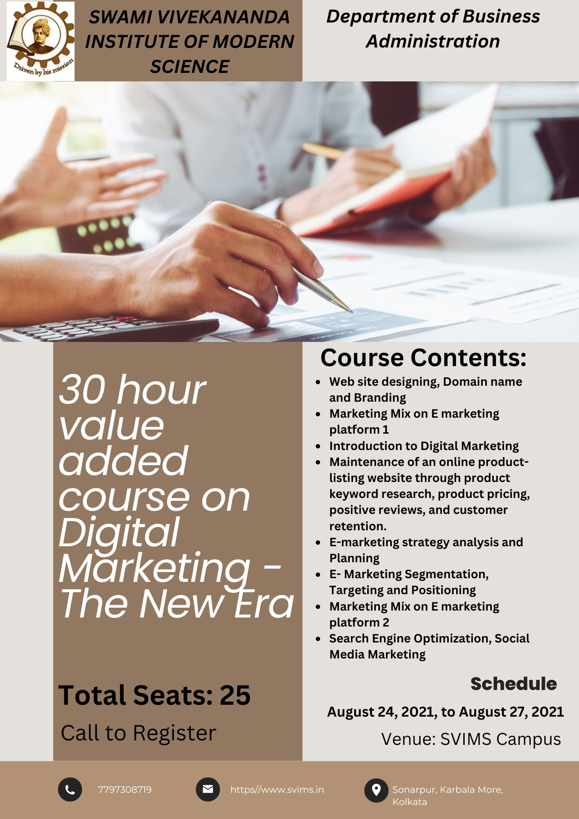

**Ref No- SVIMS/BBA(UG)/2022-23/Add-on/09 Date: 28/02/2022**

**NOTICE**

All the students of the Department of Business Administration are hereby informed that a 30-hour add-on course on ***Cyber Security and its Importance in Marketing*** is being offered. The add-on course is scheduled to be held from 07/03/2022 to 11/03/2022, spanning five days, focusing on Cyber security and its importance in Marketing.

The course objectives, course outcomes, and other details are mentioned in the course flyer. In this regard, all students are required to attend this certified course.

Course Name: ***Cyber security and its importance on Marketing.***

Mode of Class: Offline

Time of the Course: 30 Hrs,

Date: 07/03/2022- 11/03/2022

Timing: 10:30 AM to 1:30 PM and 2:00 PM to 5 PM

Venue: SVIMS Campus

For any query, contact the course coordinator mentioned in the course flyer.

By Order,



Prof. Gargi Gupta

Vice Principal

SVIMS

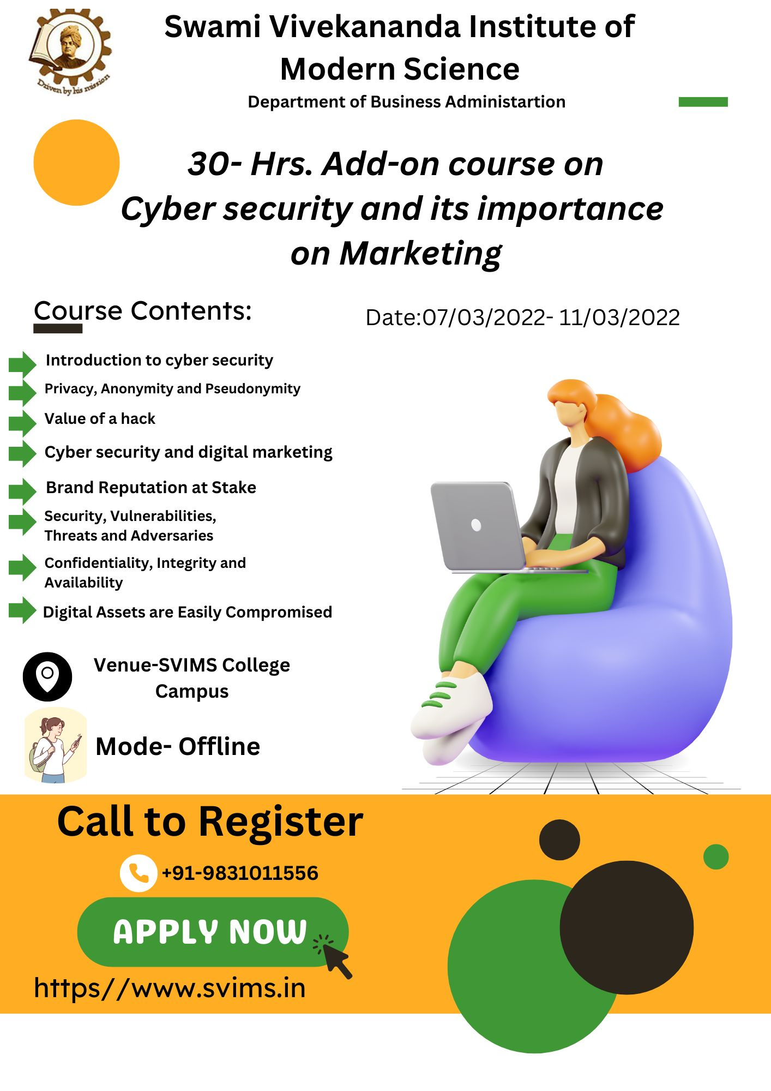



**Ref No- SVIMS/BBA(UG)/2022-23/Add-on/10 Date: 10/08/2022**

**NOTICE**

All Department of Business Administration students are being notified about an upcoming 30-hour add-on course on ***Data Representation using Advanced Excel***. The upcoming add-on course will take place from 22/08/2022 to 27/08/2022, lasting for five days. The course will primarily focus on Data Representation using advanced Excel.

The course's necessary information can be found in the course flyer. All students are required to attend this certified course.

Course Name: ***Data Representation using advanced Excel.***

Mode of Class: Offline

Time of the Course: 30 Hrs,

Date: 22/08/2022- 27/08/2022

Timing: 10:30 AM to 1:30 PM and 2:00 PM to 5 PM

Venue: SVIMS Campus

For any query, contact the course coordinator mentioned in the course flyer.

By Order,



Prof. Gargi Gupta

Vice Principal

SVIMS

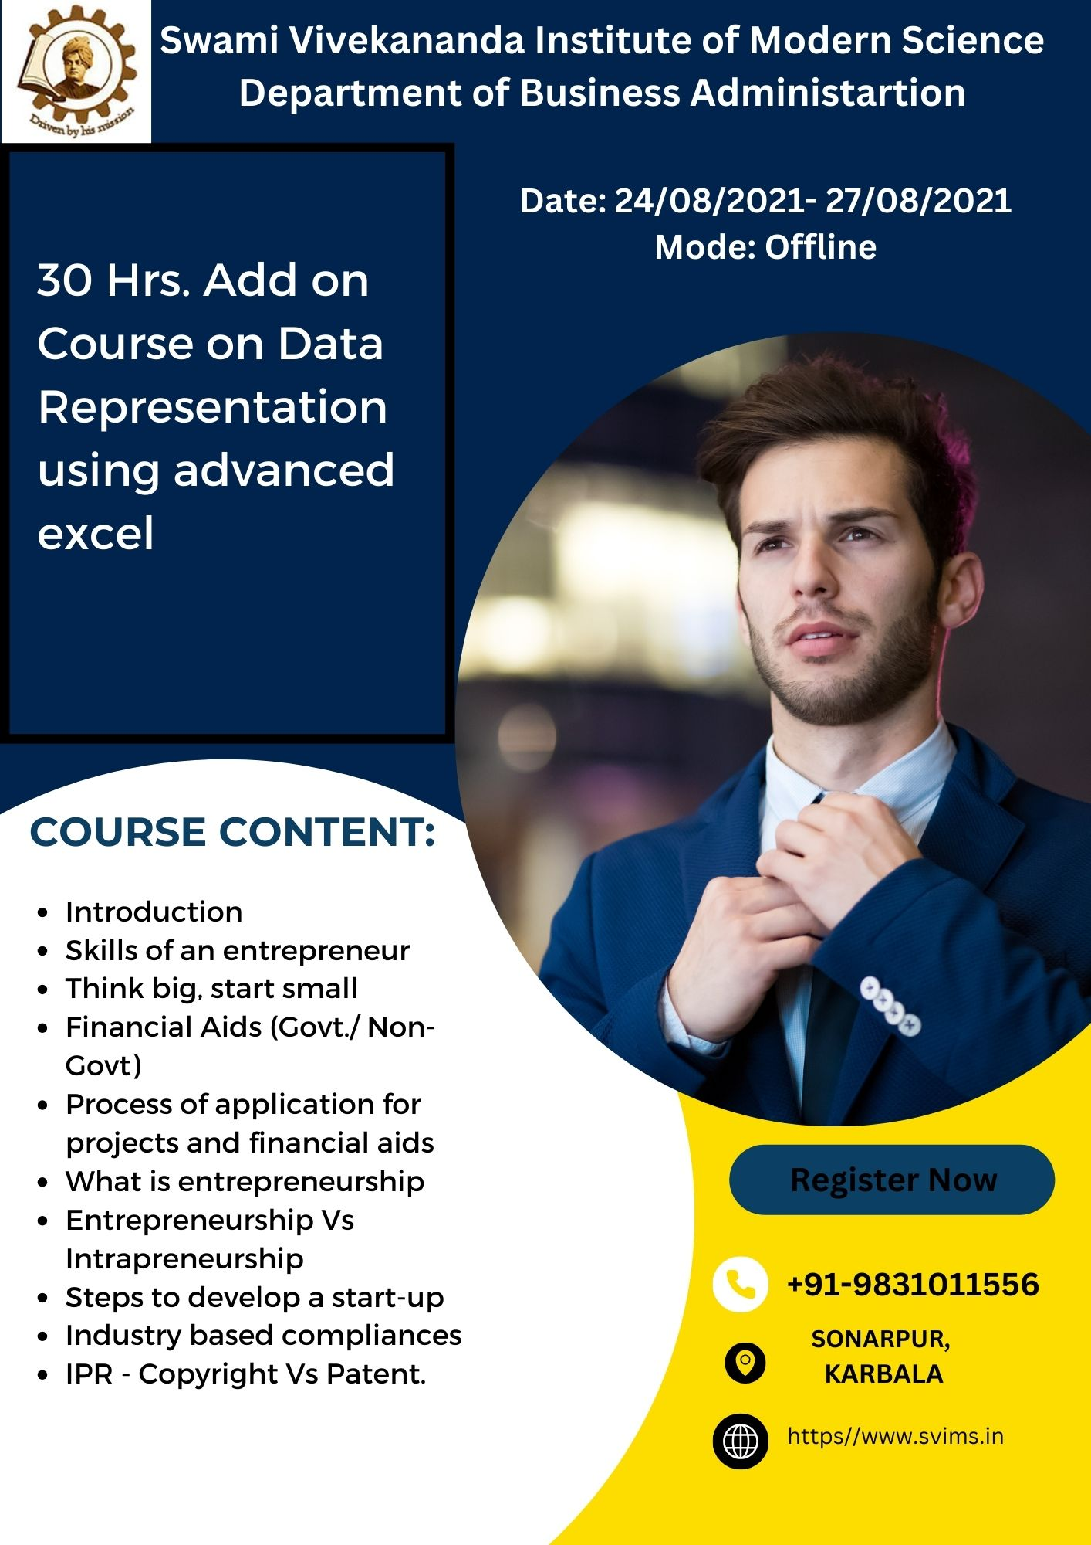

**Ref No:** SVIMS/BBA(UG)/2023/Add-On**/11** DATE:03/05/2023

NOTICE

Dear Students,

We are excited to announce a comprehensive 30-hour add-on programme on **Data Analytics with SPSS**, designed to enhance your analytical skills and boost your career prospects. This programme is meticulously crafted to provide you with hands-on experience and deep insights into the world of data analytics using one of the most potent tools, SPSS.

Those looking to enhance their analytical skills for academic research or career opportunities can grab this opportunity.

**Programme Name: Add-On Programme on Data Analytics with SPSS**

**Programme Duration:** 30 hours  
**Starting Date: 16th May 2023**

**Days: Tuesdays and Fridays**  
**Venue: SVIMS COLLEGE CAMPUS**  
**SEATS: 25**

**Time: 2:00 pm- 3: pm**

To register, scan the flyer. Feel free to contact for more information. Do not miss this opportunity to develop a valuable skill set that is highly sought after in today's data-driven world.

By Order,



Prof. Shalini Mitra

HOD, BBA

SVIMS

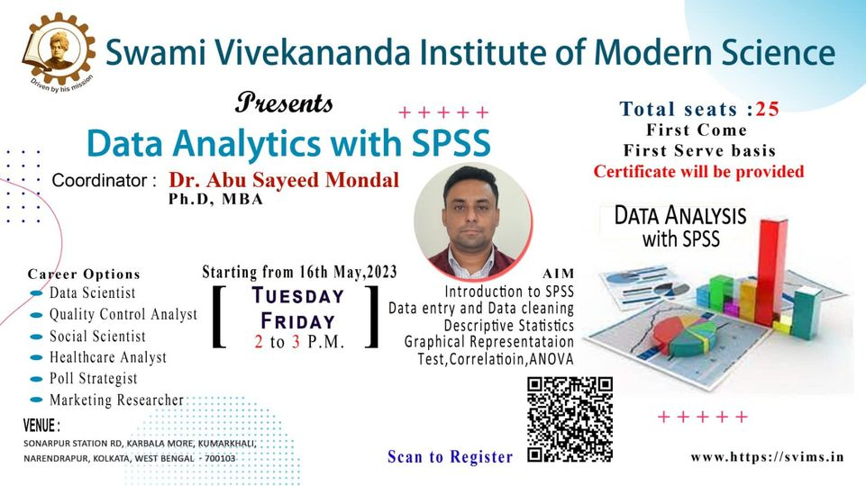

**Name of the course: 30-hour value-added course on SPSS**

**Stream**- BBA

DATE: 16/05/2023- 30/05/2023

**COURSE OBJECTIVES:**

CO 1. Students will gain foundational knowledge of data analytics and the functionalities of SPSS software.

CO 2. Students will learn techniques for preparing and cleaning datasets to ensure data quality.

CO 3. Students will be able to summarize data using descriptive statistics and create visual representations of data.

|  |  |  |  |  |  |  |  |  |  |  |  |  |
| --- | --- | --- | --- | --- | --- | --- | --- | --- | --- | --- | --- | --- |
| CO/PO | PO1 | PO2 | PO3 | PO4 | PO5 | PO6 | PO7 | PO8 | PO9 | PO10 | PO11 | PO12 |
| CO1. | 0 | 0 | 0 | 0 | 0 | 2 | 0 | 3 | 2 | 3 | 0 | 1 |
| CO2. | 0 | 0 | 1 | 0 | 0 | 1 | 1 | 1 | 2 | 3 | 1 | 1 |
| CO3. | 0 | 1 | 1 | 2 | 0 | 1 | 1 | 2 | 1 | 3 | 0 | 1 |

**Course Report: 30-Hour Value-Added Course on SPSS**

**Introduction**

The 30-hour value-added course on SPSS, conducted from 16th May 2023 to 30th May 2023, was a meticulously designed program aimed at equipping students with the knowledge and skills necessary to navigate the intricacies of data analytics using SPSS software. This report, crafted by the course coordinator, highlights the structure of the course, its objectives, and the profound impact it has on the students' learning journey.

**Course Structure**

The course was divided into ten modules, each carefully curated to cover fundamental and advanced aspects of data analytics and SPSS. The sessions were conducted in two segments: pre-lunch and post-lunch, with each session spanning three hours, ensuring a balanced and comprehensive learning experience.

1. **Module 1: Introduction to Data Analytics and SPSS (16-05-2023)**
   * The course began with an introduction to data analytics and the SPSS software. This module laid the foundation, introducing students to the basics of data handling, the importance of data analytics, and the essential features of SPSS.
2. **Module 6: Non-Parametric Tests (16-05-2023)**
   * In the post-lunch session, students delved into non-parametric tests. This module was crucial for understanding how to analyze data that do not conform to parametric assumptions, thus broadening the students' analytical toolkit.
3. **Module 2: Data Preparation and Cleaning (19-05-2023)**
   * The second day focused on the vital process of data preparation and cleaning. Students learned techniques to ensure data quality, an essential step before any meaningful analysis can be conducted.
4. **Module 7: Factor and Cluster Analysis (19-05-2023)**
   * The post-lunch session introduced students to factor and cluster analysis, powerful techniques for identifying patterns and grouping data, which are invaluable in market research and other fields.
5. **Module 3: Descriptive Statistics and Data Visualization (23-05-2023)**
   * On the third day, students explored descriptive statistics and data visualization. They learned how to summarize data using measures of central tendency and dispersion and how to create compelling visual representations of data.
6. **Module 8: Time Series Analysis (23-05-2023)**
   * The afternoon session was dedicated to time series analysis. Students were introduced to techniques for analyzing data points collected or recorded at specific time intervals, which is critical for forecasting and trend analysis.
7. **Module 4: Inferential Statistics (26-05-2023)**
   * The fourth module covered inferential statistics, enabling students to make predictions or inferences about a population based on a sample of data. This module was key to understanding hypothesis testing and confidence intervals.
8. **Module 9: Advanced Data Analytics Techniques (26-05-2023)**
   * The post-lunch session took a deep dive into advanced data analytics techniques, providing students with insights into sophisticated methods used in the field.
9. **Module 5: Regression Analysis (30-05-2023)**
   * The final pre-lunch session was devoted to regression analysis. Students learned how to model the relationship between a dependent variable and one or more independent variables, a fundamental technique in predictive analytics.
10. **Module 10: Practical Applications and Case Studies (30-05-2023)**
    * The course culminated with practical applications and case studies. This session allowed students to apply their knowledge to real-world scenarios, reinforcing their learning and demonstrating the practical utility of their skills.

**Impact on Students**

This course was instrumental in transforming the students' understanding and capabilities in data analytics. By the end of the program, students had gained a robust foundation in using SPSS for various analytical tasks. The course's hands-on approach ensured that students learned theoretical concepts and applied them practically, thus bridging the gap between theory and practice.

1. **Enhanced Analytical Skills**
   * The comprehensive coverage of both basic and advanced topics in SPSS equipped students with the skills to perform complex data analyses. They learned to handle data from initial preparation to final analysis, ensuring a thorough understanding of the analytical process.
2. **Critical Thinking and Problem-Solving**
   * The course encouraged critical thinking and problem-solving. By engaging with real-world data and case studies, students developed the ability to approach problems methodically, apply appropriate analytical techniques, and derive meaningful insights.
3. **Technical Proficiency in SPSS**
   * Through hands-on sessions, students became proficient in using SPSS. They learned to navigate the software, utilize its various features, and perform a wide range of statistical tests and analyses.
4. **Data Management Skills**
   * The data preparation, cleaning, and visualization modules were particularly beneficial in teaching students how to manage and present data effectively. These skills are essential in any data-driven role and are highly valued in the industry.
5. **Application of Advanced Techniques**
   * The introduction to advanced data analytics techniques and their practical applications ensured that students were aware of basic analytical methods and competent in applying advanced techniques. This broadened their analytical repertoire and prepared them for more complex analytical challenges.
6. **Real-World Relevance**
   * The use of practical applications and case studies throughout the course ensured that students could see the real-world relevance of their learning. This application-based approach helped solidify their understanding and demonstrated how data analytics can be used to solve actual business problems.

**Conclusion**

The 30-hour value-added course on SPSS was a resounding success, providing students with a solid foundation in data analytics and SPSS. The carefully structured modules ensured a comprehensive learning experience, from introductory concepts to advanced analytical techniques. By the end of the course, students were well-prepared to tackle complex data challenges, armed with the knowledge and skills they had acquired.

This course enhanced the students' technical proficiency and developed their critical thinking and problem-solving abilities. It bridged the gap between academic learning and practical application, making it an invaluable addition to their educational journey. The positive feedback from students and their demonstrated capabilities in using SPSS is a testament to the course's effectiveness and impact.

**Body Language & Body Movement in Media**

**Course Outcomes (COs)**

1. **CO1**: Understand the principles of body language and non-verbal communication.
2. **CO2**: Analyse body movement and its impact on media presentations.
3. **CO3**: Apply body language techniques to enhance media communication skills.

**Program Outcomes (POs)**

Program outcomes include the following:

1. **PO1**: Engineering knowledge
2. **PO2**: Problem analysis
3. **PO3**: Design/development of solutions
4. **PO4**: Conduct investigations of complex problems
5. **PO5**: Modern tool usage
6. **PO6**: The engineer and society
7. **PO7**: Environment and sustainability
8. **PO8**: Ethics
9. **PO9**: Individual and teamwork
10. **PO10**: Communication
11. **PO11**: Project management and finance
12. **PO12**: Life-long learning

**Step 3: Map COs to POs**

Mapping matrix that aligns COs with POs based on their relevance and the degree of contribution (e.g., 1 for low, 2 for medium, and 3 for high).

| **CO/PO** | **PO1** | **PO2** | **PO3** | **PO4** | **PO5** | **PO6** | **PO7** | **PO8** | **PO9** | **PO10** | **PO11** | **PO12** |
| --- | --- | --- | --- | --- | --- | --- | --- | --- | --- | --- | --- | --- |
| **CO1** | 0 | 2 | 2 | 1 | 2 | 2 | 1 | 2 | 2 | 3 | 1 | 2 |
| **CO2** | 2 | 3 | 3 | 2 | 3 | 2 | 2 | 2 | 3 | 3 | 2 | 3 |
| **CO3** | 1 | 2 | 3 | 2 | 3 | 2 | 1 | 3 | 3 | 3 | 2 | 3 |

**Explanation for Mapping**

1. **CO1: Understand the principles of body language and non-verbal communication.**

**PO1 (Engineering knowledge)**: Not Applicable

**PO2 (Problem analysis)**: Medium, as understanding body language requires analysis.

**PO3 (Design/development of solutions)**: Medium, as it involves designing communication strategies.

**PO4 (Conduct investigations of complex problems)**: Low, since investigation isn't the main focus.

**PO5 (Modern tool usage)**: Medium, understanding tools to analyze body language.

**PO6 (The engineer and society)**: Medium, since body language impacts social interactions.

**PO7 (Environment and sustainability)**: Low, minimal direct connection.

**PO8 (Ethics)**: Medium, ethical considerations in interpreting body language.

**PO9 (Individual and teamwork)**: Medium, important in team dynamics.

**PO10 (Communication)**: High, primary focus on communication.

**PO11 (Project management and finance)**: Low, limited impact.

**PO12 (Life-long learning)**: Medium, body language understanding evolves.

1. **CO2: Analyze body movement and its impact on media presentations.**

**PO1 (Engineering knowledge)**: Medium, requires knowledge application.

**PO2 (Problem analysis)**: High, involves deep analysis of body movements.

**PO3 (Design/development of solutions)**: High, designing effective media presentations.

**PO4 (Conduct investigations of complex problems)**: Medium, involves investigation.

**PO5 (Modern tool usage)**: High, using tools for analysis.

**PO6 (The engineer and society)**: Medium, societal impact of media.

**PO7 (Environment and sustainability)**: Medium, analyzing sustainability in media.

**PO8 (Ethics)**: Medium, ethical use of body movement.

**PO9 (Individual and teamwork)**: High, crucial in collaborative media work.

**PO10 (Communication)**: High, directly tied to media communication.

**PO11 (Project management and finance)**: Medium, managing media projects.

**PO12 (Life-long learning)**: High, continuous improvement in media skills.

1. **CO3: Apply body language techniques to enhance media communication skills.**

**PO1 (Engineering knowledge)**: Low, application-focused.

**PO2 (Problem analysis)**: Medium, solving communication challenges.

**PO3 (Design/development of solutions)**: High, applying techniques.

**PO4 (Conduct investigations of complex problems)**: Medium, some investigation.

**PO5 (Modern tool usage)**: High, applying tools.

**PO6 (The engineer and society)**: Medium, improving societal communication.

**PO7 (Environment and sustainability)**: Low, indirect connection.

**PO8 (Ethics)**: High, ethical application.

**PO9 (Individual and teamwork)**: High, enhances teamwork.

**PO10 (Communication)**: High, main focus.

**PO11 (Project management and finance)**: Medium, practical application in projects.

**PO12 (Life-long learning)**: High, continuous skill development.

# REPORT ON 5 DAYS VALUE ADDED COURSE ON BODY LANGUAGE & BODY MOVEMENT IN MEDIA

* **COURSE DURATION: 20-08-2018 to 24-08-2018**

# VENUE: SVIMS

* **COURSE COORDINATOR: SUNANDIT CHOWDHURY**

# TOTAL NUMBER OF PARTICIPANTS: 07

**Introduction:**

The course titled "Body Language & Body Movement in Media," hosted by the Swami Vivekananda Institute of Modern Science, turned out to be an essential tool for Media Science students. This course, divided into five days, provided a thorough examination of nonverbal communication, arming students with the necessary understanding and abilities to enhance their communication skills in an environment where visual storytelling is becoming more important.

# Course Objective:

Analyze media body language and its importance: Participants will gain an understanding of how body language is used in media to convey messages, build rapport with audiences, and create a certain impression.

Use body language effectively in front of the camera: The course will teach participants techniques for using body language to project confidence, appear engaging, and manage nervous energy on camera.

Develop methods of speaking and verbal communication: While the focus is on body language, many courses will also cover verbal communication skills such as vocal variety, pacing, and clarity, to ensure well- rounded communication.

Interpret facial expressions and their role in media: Participants will learn to read facial expressions to understand the emotions and intentions of those being filmed or interviewed.

Interpret meanings and implications of handshakes and body movements: The course will explore the cultural nuances of body language and how to interpret gestures, postures, and handshake styles.

# Course Structure:

The course was divided into theoretical session and practical workshop, ensuring a comprehensive learning experience.

Day 1: Foundations of Body Language in Media

* Morning:
  + Interactive Lecture: Introduction to nonverbal communication, its importance in media, and the power of a strong on-camera presence.
  + Group Discussion: Participants share their goals and media experiences with body language.
* Afternoon:
  + Workshop: Decoding Body Language Fundamentals - participants learn about universal and cultural nonverbal cues through interactive activities and video analysis.
  + Expert Guest Speaker (Optional): A media professional (e.g., broadcaster, coach) shares insights on using body language for impact.

Day 2: Mastering Body Language Analysis

* Morning:
  + Lecture: Understanding Body Language in Different Media Formats. Explore how body language is used strategically in interviews, presentations, documentaries, and social media.
  + Case Studies: Participants analyze real-world media examples, deconstructing body language use and its effectiveness.
* Afternoon:
  + Small Group Workshops: Participants focus on specific body language areas like facial expressions, posture, and gestures.
  + Personalized Feedback: Instructors provide individual coaching based on video recordings of participants practicing nonverbal cues.

Day 3: Body Language for Powerful Communication

* Morning:
  + Lecture: Developing Strategic Body Language Techniques. Participants learn methods for projecting confidence, managing stage presence, and using body language to enhance their message.
  + Interactive Activity: Participants experiment with different body language techniques in mock interviews or presentations, receiving feedback from peers and instructors.
* Afternoon:
  + Workshop: Integrating Body Language with Vocal Communication. Participants explore vocal variety, pacing, and clarity to create a cohesive communication package.
  + Video Analysis and Development Plan: Participants review their video recordings with an instructor to personalize an action plan for improvement.

Day 4: Building On-Camera Confidence

* Morning:
  + Lecture: Overcoming Camera Anxiety and Developing On-Camera Presence. Participants learn techniques for managing nervousness and projecting confidence.
  + Group Discussion: Participants share personal experiences and strategies for overcoming camera anxiety.
* Afternoon:
  + Scenario-Based Practice Sessions: Participants work in small groups to practice body language and vocal communication skills in simulated media scenarios (e.g., news interview, social media video).
  + Peer Feedback and Coaching: Participants receive constructive feedback from peers and instructors to refine their on-camera communication.

Day 5: Putting It All Together

* Morning:
  + Review and Q&A Session: Consolidate learnings from the course and address any remaining questions.
  + Course Wrap-Up: Participants share their key takeaways and discuss future goals.
* Afternoon:
  + Final Showcase (Optional): Participants have the option to present a short media piece (e.g., interview, pitch) showcasing their learned skills, receiving final feedback and encouragement from the group.
  + Networking Session (Optional): This value-added element allows participants to connect with instructors, guest speakers, and fellow participants to build professional relationships.

# Participation Feedback:

The 5-day value-added course on Body Language & Body Movement in Media sounds like a comprehensive and engaging program. The interactive structure, focus on practical skills, and inclusion of industry expertise likely led to a positive learning experience for participants.

# Conclusion:

The "Body Language & Body Movement in Media" course offered by the Swami Vivekananda Institute of Modern Science empowered Media Science students with a powerful toolset for success in their chosen field.

By understanding and mastering the art of nonverbal communication, these students are now better equipped to not only interpret the messages conveyed by others but also to craft their own impactful and compelling media narratives.

**Business Journalism**

**Course Outcomes (COs):**

* **CO1:** Develop an understanding of key business journalism concepts and practices.
* **CO2:** Acquire skills to effectively report and analyze business news.
* **CO3:** Demonstrate ethical standards and professional integrity in business journalism.

**Program Outcomes (POs):**

* **PO1:** Knowledge and understanding of media and journalism fundamentals.
* **PO2:** Proficiency in writing and reporting for various media.
* **PO3:** Critical thinking and analytical skills.
* **PO4:** Technical skills in media production and communication.
* **PO5:** Understanding of media laws and ethics.
* **PO6:** Research skills in media and communication studies.
* **PO7:** Ability to work effectively in teams.
* **PO8:** Effective communication skills.
* **PO9:** Understanding of global media landscapes and trends.
* **PO10:** Project management skills in media contexts.
* **PO11:** Professionalism and ethical practices.
* **PO12:** Lifelong learning and adaptability in media careers.

**Mapping Matrix:**

Mapping matrix that aligns COs with POs based on their relevance and the degree of contribution (e.g., 1 for low, 2 for medium, and 3 for high).

| **CO\PO** | **PO1** | **PO2** | **PO3** | **PO4** | **PO5** | **PO6** | **PO7** | **PO8** | **PO9** | **PO10** | **PO11** | **PO12** |
| --- | --- | --- | --- | --- | --- | --- | --- | --- | --- | --- | --- | --- |
| CO1 | 3 | 2 | 3 | 1 | 2 | 2 | 1 | 2 | 3 | 1 | 2 | 1 |
| CO2 | 2 | 3 | 3 | 2 | 2 | 3 | 2 | 3 | 2 | 2 | 2 | 2 |
| CO3 | 2 | 2 | 2 | 1 | 3 | 1 | 2 | 2 | 1 | 1 | 3 | 2 |

**Explanation of the Mapping:**

* **CO1 (Develop an understanding of key business journalism concepts and practices) mapped to POs:**

**PO1:** High correlation (3) as it directly involves understanding media and journalism fundamentals.

**PO2:** Medium correlation (2) as understanding concepts aids in writing/reporting.

**PO3:** High correlation (3) due to the need for analytical skills in understanding business journalism.

**PO4:** Low correlation (1) since technical skills are less directly related.

**PO5:** Medium correlation (2) as understanding includes ethical considerations.

**PO6:** Medium correlation (2) due to the research component in understanding concepts.

**PO7:** Low correlation (1) as team work is less emphasized.

**PO8:** Medium correlation (2) due to the importance of communication skills.

**PO9:** High correlation (3) because understanding trends is crucial.

**PO10:** Low correlation (1) since project management is less emphasized.

**PO11:** Medium correlation (2) due to the ethical standards.

**PO12:** Low correlation (1) as lifelong learning is less directly connected.

* **CO2 (Acquire skills to effectively report and analyze business news) mapped to POs:**

**PO1:** Medium correlation (2) as fundamental knowledge aids in reporting.

**PO2:** High correlation (3) due to the direct relevance to writing/reporting.

**PO3:** High correlation (3) because analytical skills are critical.

**PO4:** Medium correlation (2) due to some technical skills required.

**PO5:** Medium correlation (2) due to ethical reporting.

**PO6:** High correlation (3) because research skills are essential.

**PO7:** Medium correlation (2) as teamwork can be involved.

**PO8:** High correlation (3) for effective communication.

**PO9:** Medium correlation (2) due to understanding global trends.

**PO10:** Medium correlation (2) for managing reporting projects.

**PO11:** Medium correlation (2) due to professionalism.

**PO12:** Medium correlation (2) as adaptability is important.

* **CO3 (Demonstrate ethical standards and professional integrity in business journalism) mapped to POs:**

**PO1:** Medium correlation (2) as ethics are part of fundamental knowledge.

**PO2:** Medium correlation (2) as ethics influence reporting.

**PO3:** Medium correlation (2) because ethical standards require critical thinking.

**PO4:** Low correlation (1) since technical skills are less relevant.

**PO5:** High correlation (3) as it directly involves ethics.

**PO6:** Low correlation (1) since research skills are less directly related.

**PO7:** Medium correlation (2) because ethical practices can involve teamwork.

**PO8:** Medium correlation (2) as communication must be ethical.

**PO9:** Low correlation (1) since global trends are less relevant.

**PO10:** Low correlation (1) as project management is less relevant.

**PO11:** High correlation (3) directly related to professionalism and ethics.

**PO12:** Medium correlation (2) as ethics involve lifelong learning.

# REPORT ON 5 DAYS VALUE ADDED COURSE ON BUSINESS JOURNALISM

* **COURSE DURATION: 15-11-2018 to 19-11-2018**

# VENUE: SVIMS

* **COURSE COORDINATOR: MANAB DATTA**

# TOTAL NUMBER OF PARTICIPANTS: 07

**Introduction:**

The Value-Added Course on Business Journalism is designed to equip participants with the skills and knowledge necessary to excel in the field of business journalism. This course covers a range of topics from understanding economic indicators to reporting on financial markets and corporate affairs. Participants will learn how to effectively gather, analyse, and present business news in a compelling and accurate manner.

# Course Objective:

1. Foundational Knowledge:
   * Establish a strong understanding of core business concepts like finance, economics, and accounting. This forms the bedrock for analysing complex business issues.
2. Business Reporting Expertise:
   * Develop mastery in crafting compelling stories about companies, markets, and trends. This includes learning various story formats, interview techniques, and effective research methods.
3. Data-Driven Insights:
   * Cultivate the ability to leverage data analysis in business journalism. Learn tools and techniques to decipher financial statements, market data, and other forms of business information.
4. Navigating the Landscape:
   * Gain insights into the current state of business journalism, including the rise of online media and the evolving role of journalists in the digital age.
5. Develop Practical Skills:
   * Hone the ability to identify and research newsworthy business stories.
   * Master effective interview techniques to extract valuable information from key figures.
   * Learn to analyze and interpret complex financial data to inform your reporting.
   * Craft clear, concise, and engaging business journalism pieces.
6. Career Advancement:
   * Enhance critical thinking and analytical skills crucial for success in business journalism.
   * Build the confidence to pursue a career in business journalism.

# Course Structure:

The course was divided into theoretical session and practical workshop, ensuring a comprehensive learning experience. This intensive 5-day program offers a comprehensive and engaging learning experience. Here's a breakdown of the potential structure:

# Day 1: Foundations of Business

* + **Morning:** Introduction to Business Journalism: Course overview, career opportunities, and the evolving media landscape.
  + **Afternoon:** Core Business Concepts: Demystifying finance, economics, and accounting principles to understand business operations and performance.
  + **Interactive Activities:** Case studies and discussions to apply knowledge to real-world business scenarios.

# Day 2: The Art of Business Reporting

* + **Morning:** Crafting Compelling Stories: Exploring different story formats in business journalism (e.g., news articles, feature stories, investigative pieces).
  + **Afternoon:** Interview Techniques: Mastering the art of conducting insightful interviews with industry experts and company representatives.
  + **Workshop:** Participants practice conducting mock interviews and receive feedback.

# Day 3: Unveiling the Data Story

* + **Morning:** Data Analysis for Journalists: Introduction to tools and techniques for analyzing financial statements, market data, and other business information.
  + **Afternoon:** Data Visualization: Learning how to effectively present data through charts, graphs, and infographics to enhance your stories.
  + **Hands-on Session:** Participants work with real-world data sets and create data visualizations using industry-standard software (or online tools).

# Day 4: Business Journalism in the Digital Age

* + **Morning:** The Rise of Online Media: Exploring the impact of digital platforms on business journalism and strategies for successful online content creation.
  + **Afternoon:** Ethics and Best Practices: Discussing ethical considerations in business journalism, data sourcing, and ensuring information accuracy.
  + **Guest Speaker:** Invite a renowned business journalist to share their experiences and insights on navigating the digital landscape.

# Day 5: Putting It All Together

* + **Morning:** Project Development: Participants choose a business-related topic and develop a comprehensive business journalism piece, using the skills learned throughout the course.
  + **Afternoon:** Presentations and Feedback: Participants present their work and receive constructive feedback from instructors and peers.
  + **Wrap-up:** Course conclusion, Q&A, and resource sharing for further learning.

# Participation Feedback:

The Value-Added Course on Business Journalism has received positive feedback from participants who appreciate its comprehensive curriculum, practical approach, and industry relevance. The Value-Added Course on Business Journalism has been well-received for its comprehensive and practical approach. While there are areas for improvement, such as increasing hands-on workshops and enhancing interactive elements, the overall feedback indicates that the course effectively prepares participants for a successful career in business journalism.

# Conclusion:

The value-added course on Business Journalism was highly beneficial, equipping students with essential skills and knowledge for the field. While there are areas for improvement, particularly in resource accessibility, course pacing, and feedback mechanisms, the strengths of the course in terms of content, teaching methodology, and practical application outweigh the weaknesses. Future iterations of the course could build on these strengths while addressing the identified areas for improvement to enhance the overall learning experience.

**CO & PO Mapping for Value Added courses**

**DEPARTMENT OF MEDIA SCIENCE**

**Innovation And Entrepreneurship Management**

**Course Outcomes (COs)**

1. **CO1**: Understand the principles of innovation and entrepreneurship.
2. **CO2**: Apply techniques of business model generation and validation.
3. **CO3**: Develop strategies for successful startup management and growth.

**Program Outcomes (POs)**

Program outcomes include the following:

1. **PO1**: Engineering knowledge.
2. **PO2**: Problem analysis.
3. **PO3**: Design/development of solutions.
4. **PO4**: Conduct investigations of complex problems.
5. **PO5**: Modern tool usage.
6. **PO6**: The engineer and society.
7. **PO7**: Environment and sustainability.
8. **PO8**: Ethics.
9. **PO9**: Individual and teamwork.
10. **PO10**: Communication.
11. **PO11**: Project management and finance.
12. **PO12**: Life-long learning.

**Mapping Matrix**

Mapping matrix that aligns COs with POs based on their relevance and the degree of contribution (e.g., 1 for low, 2 for medium, and 3 for high).

| **CO\PO** | **PO1** | **PO2** | **PO3** | **PO4** | **PO5** | **PO6** | **PO7** | **PO8** | **PO9** | **PO10** | **PO11** | **PO12** |
| --- | --- | --- | --- | --- | --- | --- | --- | --- | --- | --- | --- | --- |
| CO1 | 3 | 2 | 2 | 1 | 2 | 3 | 2 | 1 | 1 | 2 | 2 | 3 |
| CO2 | 2 | 3 | 3 | 2 | 3 | 2 | 1 | 1 | 2 | 3 | 3 | 2 |
| CO3 | 2 | 2 | 3 | 2 | 3 | 2 | 2 | 3 | 3 | 3 | 3 | 3 |

**Explanation of the Mapping**

1. **CO1 - Understand the principles of innovation and entrepreneurship:**

**PO1 (Engineering knowledge)**: High (3) - Understanding innovation requires strong foundational knowledge.

**PO2 (Problem analysis)**: Medium (2) - Innovation involves identifying and analyzing problems.

**PO3 (Design/development of solutions)**: Medium (2) - Principles of innovation help in designing solutions.

**PO4 (Investigations)**: Low (1) - Basic understanding aids in initial investigations.

**PO5 (Modern tool usage)**: Medium (2) - Innovation often involves modern tools.

**PO6 (Engineer and society)**: High (3) - Innovation impacts society significantly.

**PO7 (Environment and sustainability)**: Medium (2) - Sustainable innovation is a key consideration.

**PO8 (Ethics)**: Low (1) - Ethical considerations in innovation are important.

**PO9 (Individual and teamwork)**: Low (1) - Basic understanding of teamwork in innovation.

**PO10 (Communication)**: Medium (2) - Essential for articulating innovative ideas.

**PO11 (Project management and finance)**: Medium (2) - Innovation principles aid in project management.

**PO12 (Life-long learning)**: High (3) - Continuous learning is crucial in innovation.

1. **CO2 - Apply techniques of business model generation and validation:**

**PO1**: Medium (2) - Requires application of engineering knowledge.

**PO2**: High (3) - Critical for analyzing business problems.

**PO3**: High (3) - Directly related to developing business solutions.

**PO4**: Medium (2) - Involves investigation and validation.

**PO5**: High (3) - Utilizes modern business tools.

**PO6**: Medium (2) - Business models impact society.

**PO7**: Low (1) - Some consideration of sustainability.

**PO8**: Low (1) - Ethical business practices.

**PO9**: Medium (2) - Collaboration in business model generation.

**PO10**: High (3) - Critical for communicating business ideas.

**PO11**: High (3) - Central to project management and finance.

**PO12**: Medium (2) - Learning new business techniques is ongoing.

1. **CO3 - Develop strategies for successful startup management and growth:**

**PO1**: Medium (2) - Applies engineering knowledge in strategy.

**PO2**: Medium (2) - Analyzing startup challenges.

**PO3**: High (3) - Strategy development is key to solutions.

**PO4**: Medium (2) - Investigative strategies.

**PO5**: High (3) - Modern tools for management.

**PO6**: Medium (2) - Startups’ societal impact.

**PO7**: Medium (2) - Sustainable growth strategies.

**PO8**: High (3) - Ethical management practices.

**PO9**: High (3) - Teamwork in startup management.

**PO10**: High (3) - Communication for strategy implementation.

**PO11**: High (3) - Financial strategies for growth.

**PO12**: High (3) - Adapting to changes in the startup ecosystem.

**REPORT ON 5 DAYS VALUE ADDED COURSE ON**

**INNOVATION AND ENTREPRENEURSHIP MANAGEMENT**

* **COURSE DURATION: 11-02-2019 to 15-02-2019**
* **VENUE: SVIMS**
* **COURSE COORDINATOR: SUSHWATA ROY**
* **TOTAL NUMBER OF PARTICIPANTS: 08**

# Introduction:

The 5-Day Value-Added Course on Innovation and Entrepreneurship Management was conducted from 11- 02-2019 to 15-02-2019. The course aimed to equip participants with essential skills and knowledge in innovation, entrepreneurial thinking, and effective management practices. It was attended by aspiring entrepreneurs, business professionals, and students from various academic backgrounds.

# Course Objective:

* To understand the fundamentals of innovation and entrepreneurship.
* To develop the ability to create and manage innovative ventures.
* To enhance problem-solving and critical-thinking skills.
* To learn best practices in managing entrepreneurial ventures.

# Course Structure:

The course was divided into theoretical session and practical workshop, ensuring a comprehensive learning experience. This intensive 5-day program offers a comprehensive and engaging learning experience. Here's a breakdown of the potential structure:

Day 1: Introduction to Innovation and Entrepreneurship Topics Covered:

* Definition and significance of innovation and entrepreneurship.
* Characteristics of successful entrepreneurs.
* Types of innovation: incremental, disruptive, and radical.
* The entrepreneurial mindset. Activities:
* Ice-breaking session and participant introductions.
* Case study analysis of a successful startup.
* Group discussion on entrepreneurial traits and qualities.

Day 2: Ideation and Opportunity Recognition Topics Covered:

* Techniques for generating innovative ideas.
* Identifying and evaluating business opportunities.
* Market research and feasibility analysis.
* Design thinking and its application in entrepreneurship. Activities:
* Brainstorming session on potential business ideas.
* Workshop on conducting market research.
* Role-playing exercise on opportunity evaluation.

Day 3: Business Model Development Topics Covered:

* Components of a business model.
* Business Model Canvas: tool for visualizing and developing business models.
* Value proposition and customer segmentation.
* Revenue streams and cost structures. Activities:
* Interactive session on creating a Business Model Canvas.
* Group exercise on developing a business model for a hypothetical product.
* Presentation and critique of group business models.

Day 4: Funding and Financial Management Topics Covered:

* Sources of funding for startups (angel investors, venture capital, crowdfunding, etc.).
* Financial planning and budgeting.
* Key financial statements: income statement, balance sheet, and cash flow statement.
* Managing startup finances effectively. Activities:
* Workshop on creating a financial plan for a startup.
* Simulation game on managing a startup’s finances.
* Panel discussion with venture capitalists and angel investors.

Day 5: Scaling and Managing Growth Topics Covered:

* Strategies for scaling a business.
* Managing organizational growth and change.
* Building a strong team and company culture.
* Leveraging technology for business growth. Activities:
* Case study analysis of a company that successfully scaled.
* Group activity on developing a growth strategy.
* Reflection session on key takeaways and action plans.

# Participation Feedback:

* The course received overwhelmingly positive feedback, with participants appreciating the practical approach and real-world applications.
* The interactive sessions and expert speakers were particularly highlighted as valuable components.
* Participants suggested including more hands-on activities and extended Q&A sessions with guest speakers.

**Conclusion:** The 5-Day Value-Added Course on Innovation and Entrepreneurship Management successfully achieved its objectives, providing participants with the necessary tools and knowledge to foster innovation and manage entrepreneurial ventures. The blend of theoretical knowledge, practical exercises, and expert insights ensured a comprehensive learning experience.

**CO & PO Mapping for Value Added courses**

**DEPARTMENT OF MEDIA SCIENCE**

**Basics Of Film Making**

**Course Outcomes (COs)**

* **CO1:** Understand the fundamental concepts and techniques of film making.
* **CO2:** Develop practical skills in using film making equipment and software.
* **CO3:** Analyse and critique films to understand the elements of storytelling, cinematography, and editing.

**Program Outcomes (POs)**

Program outcomes include the following:

**PO1:** Engineering Knowledge

**PO2:** Problem Analysis

**PO3:** Design/Development of Solutions

**PO4:** Conduct Investigations of Complex Problems

**PO5:** Modern Tool Usage

**PO6:** The Engineer and Society

**PO7:** Environment and Sustainability

**PO8:** Ethics

**PO9:** Individual and Team Work

**PO10:** Communication

**PO11:** Project Management and Finance

**PO12:** Life-long Learning

**Mapping Matrix**

Here's the mapping matrix showing the relationship between COs and POs. The scale used is 3 (High), 2 (Medium), and 1 (Low).

| **COs/POs** | **PO1** | **PO2** | **PO3** | **PO4** | **PO5** | **PO6** | **PO7** | **PO8** | **PO9** | **PO10** | **PO11** | **PO12** |
| --- | --- | --- | --- | --- | --- | --- | --- | --- | --- | --- | --- | --- |
| CO1 | 3 | 2 | 2 | 1 | 2 | 1 | 1 | 2 | 2 | 2 | 1 | 3 |
| CO2 | 2 | 2 | 3 | 2 | 3 | 1 | 2 | 1 | 3 | 2 | 2 | 2 |
| CO3 | 2 | 3 | 2 | 3 | 2 | 2 | 1 | 3 | 2 | 3 | 1 | 3 |

**Explanation of Mapping**

**CO1: Understand the fundamental concepts and techniques of film making.**

**PO1 (Engineering Knowledge):** High understanding required of basic film making principles (High).

**PO2 (Problem Analysis):** Medium as students analyze film techniques (Medium).

**PO3 (Design/Development of Solutions):** Medium, applying concepts in practical scenarios (Medium).

**PO4 (Conduct Investigations of Complex Problems):** Low, involves minimal investigation (Low).

**PO5 (Modern Tool Usage):** Medium as students use film making tools (Medium).

**PO6 (The Engineer and Society):** Low, some societal impact (Low).

**PO7 (Environment and Sustainability):** Low, minimal relevance (Low).

**PO8 (Ethics):** Medium, as ethics in film making are discussed (Medium).

**PO9 (Individual and Team Work):** Medium, involves teamwork (Medium).

**PO10 (Communication):** Medium, requires good communication (Medium).

**PO11 (Project Management and Finance):** Low, some project management aspects (Low).

**PO12 (Life-long Learning):** High, foundational knowledge fosters lifelong learning (High).

**CO2: Develop practical skills in using film making equipment and software.**

**PO1 (Engineering Knowledge):** Medium, technical knowledge application (Medium).

**PO2 (Problem Analysis):** Medium, troubleshooting skills (Medium).

**PO3 (Design/Development of Solutions):** High, creating film projects (High).

**PO4 (Conduct Investigations of Complex Problems):** Medium, solving technical issues (Medium).

**PO5 (Modern Tool Usage):** High, extensive use of modern tools (High).

**PO6 (The Engineer and Society):** Low, limited societal impact (Low).

**PO7 (Environment and Sustainability):** Medium, environmental impact of production (Medium).

**PO8 (Ethics):** Low, ethical considerations (Low).

**PO9 (Individual and Team Work):** High, requires teamwork (High).

**PO10 (Communication):** Medium requires good communication (Medium).

**PO11 (Project Management and Finance):** Medium, some project management (Medium).

**PO12 (Life-long Learning):** Medium, ongoing learning of new tools (Medium).

**CO3: Analyse and critique films to understand the elements of storytelling, cinematography, and editing.**

**PO1 (Engineering Knowledge):** Medium, theoretical understanding (Medium).

**PO2 (Problem Analysis):** High, critical analysis skills (High).

**PO3 (Design/Development of Solutions):** Medium, applying critiques to improve designs (Medium).

**PO4 (Conduct Investigations of Complex Problems):** High, in-depth film analysis (High).

**PO5 (Modern Tool Usage):** Medium, tools for analysis (Medium).

**PO6 (The Engineer and Society):** Medium, societal impact of films (Medium).

**PO7 (Environment and Sustainability):** Low, minimal relevance (Low).

**PO8 (Ethics):** High, ethical storytelling (High).

**PO9 (Individual and Team Work):** Medium, collaboration in critique sessions (Medium).

**PO10 (Communication):** High, critical feedback and discussions (High).

**PO11 (Project Management and Finance):** Low, minimal relevance (Low).

**PO12 (Life-long Learning):** High, ongoing learning through critique (High).

# REPORT ON 5 DAYS VALUE ADDED COURSE ON BASICS OF FILM MAKING

* **COURSE DURATION: 11-05-2020 to 15-05-2020**

# VENUE: SVIMS

* **COURSE COORDINATOR: MANAB DATTA**

# TOTAL NUMBER OF PARTICIPANTS: 23

**Introduction:**

This report provides an overview of the 30-hour online value-added course on the Basics of Filmmaking. The course was designed to offer participants a comprehensive introduction to the key elements of filmmaking, from scriptwriting to post-production. It aimed to equip learners with both theoretical knowledge and practical skills essential for creating short films.

# Course Objective:

* To understand the fundamental principles of filmmaking.
* To develop skills in scripting, directing, cinematography, and editing.
* To learn best practices in film project management and teamwork.

# Course Structure:

The course was structured into daily modules, each focusing on a key aspect of filmmaking. Each day included theoretical sessions, practical exercises, and interactions with industry professionals. The course was divided into eight modules, each focusing on a critical area of filmmaking. The modules were as follows:

1. Introduction and Overview
2. Scriptwriting Basics
3. Planning Your Film
4. Casting and Location Scouting
5. Cinematography Basics
6. Sound and Music
7. Editing Fundamentals
8. Special Effects and Color Grading

DAY 1- Introduction and Overview & Scriptwriting Basics

* Overview of filmmaking history and industry.
* Different film genres and styles.
* Roles and responsibilities in a film crew.
* Basics of screenplay structure.
* Character development and plot building.
* Creating storyboards to plan visual sequences.

DAY 2- Planning Your Film & Casting and Location Scouting

* Directing principles and techniques.
* Managing actors and crew on set.
* Translating a script into a visual story.
* Designing sets and selecting locations.
* Importance of costumes, props, and makeup.
* Creating a cohesive visual style.

DAY 3- Cinematography Basics & Sound and Music

* Types of cameras and lenses.
* Fundamental camera movements and shot composition.
* Techniques for achieving continuity in shooting.
* Basics of lighting design for film.
* Techniques for natural and artificial lighting.
* Sound recording methods and equipment.
* Editing Fundamentals DAY 4 Special Effects
* Introduction to video editing software.
* Basic editing techniques: cutting, transitions, and effects.

DAY 5 Color Grading

* Overview of color correction and sound editing.
* Editing and presenting the final project.

# Participation Feedback:

* **Comprehensive Curriculum:** Participants appreciated the breadth and depth of the topics covered.
* **Instructor Expertise:** The instructors were praised for their knowledge, clarity, and responsiveness.
* **Collaborative Environment:** The course fostered a strong sense of teamwork (ONLINE GROUP) and collaboration.

# Conclusion:

The 30-hour online course on Basics of Filmmaking successfully provided participants with essential knowledge and skills in film production. By combining theoretical instruction, the course enabled participants to gain confidence and competence in various aspects of filmmaking. The positive feedback suggests a strong interest in continuing and expanding such educational offerings in the future.

**CO & PO Mapping for Value Added courses**

**DEPARTMENT OF MEDIA SCIENCE**

**Radio Jockey and Radio Broadcasting**

**Course Outcomes (COs)**

* **CO1:** Mastering Broadcasting Techniqu**es**
* **CO2:** Understanding Media Regulations and Ethics
* **CO3:** Developing Creative Content

**Program Outcomes (POs)**

Program outcomes include the following:

* **PO1:** Engineering Knowledge
* **PO2:** Problem Analysis
* **PO3:** Design/Development of Solutions
* **PO4:** Conduct Investigations of Complex Problems
* **PO5:** Modern Tool Usage
* **PO6:** The Engineer and Society
* **PO7:** Environment and Sustainability
* **PO8:** Ethics
* **PO9:** Individual and Team Work
* **PO10:** Communication
* **PO11:** Project Management and Finance
* **PO12:** Life-long Learning

**Mapping Matrix**

Here's the mapping matrix showing the relationship between COs and POs. The scale used is 3 (High), 2 (Medium), and 1 (Low).

| **COs/POs** | **PO1** | **PO2** | **PO3** | **PO4** | **PO5** | **PO6** | **PO7** | **PO8** | **PO9** | **PO10** | **PO11** | **PO12** |
| --- | --- | --- | --- | --- | --- | --- | --- | --- | --- | --- | --- | --- |
| CO1 | 3 | 2 | 3 | 2 | 3 | 2 | 1 | 2 | 3 | 3 | 2 | 2 |
| CO2 | 2 | 2 | 2 | 3 | 2 | 3 | 2 | 3 | 2 | 2 | 2 | 3 |
| CO3 | 3 | 3 | 3 | 3 | 3 | 2 | 2 | 2 | 3 | 3 | 2 | 3 |

**Explanation of Mapping**

**CO1: Mastering Broadcasting Techniques**

**PO1: Engineering Knowledge** - This is relevant as mastering broadcasting techniques involves understanding the technical aspects of radio equipment and software (High).

**PO2: Problem Analysis** - Students must be able to analyze and solve issues related to live broadcasting (Medium).

**PO3: Design/Development of Solutions** - Designing effective broadcasting techniques and solutions (High).

**PO4: Conduct Investigations of Complex Problems** - Investigating technical and logistical issues during broadcasts (Medium).

**PO5: Modern Tool Usage** - Proficiency in modern broadcasting tools (High).

**PO6: The Engineer and Society** - Understanding societal impact and audience engagement (Medium).

**PO7: Environment and Sustainability** - Limited relevance but can consider sustainable practices in broadcasting (Low).

**PO8: Ethics** - Adhering to ethical broadcasting standards (Medium).

**PO9: Individual and Team Work** - Effective teamwork during broadcasts (High).

**PO10: Communication** - Key aspect of radio jockeying (High).

**PO11: Project Management and Finance** - Managing broadcasting projects (Medium).

**PO12: Life-long Learning** - Continual improvement in broadcasting skills (Medium).

**CO2: Understanding Media Regulations and Ethics**

**PO1: Engineering Knowledge** - Basic understanding of regulations (Medium).

**PO2: Problem Analysis** - Analyzing legal and ethical issues (Medium).

**PO3: Design/Development of Solutions** - Creating ethical broadcasting solutions (Medium).

**PO4: Conduct Investigations of Complex Problems** - Investigating regulatory issues (High).

**PO5: Modern Tool Usage** - Ensuring tools comply with regulations (Medium).

**PO6: The Engineer and Society** - Understanding societal impact of media regulations (High).

**PO7: Environment and Sustainability** - Considering regulations related to environmental impact (Medium).

**PO8: Ethics** - Central to this CO (High).

**PO9: Individual and Team Work** - Working in teams to ensure compliance (Medium).

**PO10: Communication** - Clear communication of regulations (Medium).

**PO11: Project Management and Finance** - Managing projects within legal frameworks (Medium).

**PO12: Life-long Learning** - Keeping up with evolving regulations (High).

**CO3: Developing Creative Content**

**PO1: Engineering Knowledge** - Applying knowledge to content creation (High).

**PO2: Problem Analysis** - Solving content creation challenges (High).

**PO3: Design/Development of Solutions** - Central to this CO (High).

**PO4: Conduct Investigations of Complex Problems** - Investigating new content ideas (High).

**PO5: Modern Tool Usage** - Utilizing tools for content creation (High).

**PO6: The Engineer and Society** - Creating content that reflects societal values (Medium).

**PO7: Environment and Sustainability** - Creating content with a focus on sustainability (Medium).

**PO8: Ethics** - Ensuring ethical content (Medium).

**PO9: Individual and Team Work** - Collaborative content creation (High).

**PO10: Communication** - Effective communication through content (High).

**PO11: Project Management and Finance** - Managing content production (Medium).

**PO12: Life-long Learning** - Innovating and improving content over time (High).

# REPORT ON 5 DAYS VALUE ADDED COURSE ON RADIO JOCKEY AND RADIO BROADCASTING

* **COURSE DURATION: 19-08-2019 to 23-08-2019**

# VENUE: SVIMS

* **COURSE COORDINATOR: SUSHWATA ROY**

# TOTAL NUMBER OF PARTICIPANTS: 21

**Introduction:**

The course on Radio Jockey and Radio Broadcasting was held from 19-08-2019 to 23-08-2019. The primary goal was to equip participants with essential skills and knowledge for a successful career in radio broadcasting. The course was well- attended by aspiring radio jockeys (RJs), journalism students, and media professionals.

# Course Objective:

* To understand the fundamentals of radio broadcasting and the role of a radio jockey.
* To develop skills in voice modulation, scripting, and engaging storytelling.
* To enhance on-air presence and communication skills.
* To learn best practices in radio production and station operations.

# Course Structure:

The five-day course was structured into modules focusing on various aspects of radio jockeying and broadcasting. Each day included theoretical sessions, practical exercises, and interactions with industry experts.

Day 1: Introduction to Radio Broadcasting and Jockeying Topics Covered:

* Overview of the radio industry and its evolution.
* Roles and responsibilities of a radio jockey.
* Key qualities of a successful RJ.
* Ethical considerations in radio broadcasting.

Activities:

* Ice-breaking session and participant introductions.
* Group discussion on the impact of radio in modern media.
* Analysis of popular radio shows and notable RJs.

Day 2: Voice Modulation and On-Air Techniques Topics Covered:

* Techniques for effective voice modulation.
* Importance of diction, pitch, and pace in radio.
* Developing a unique on-air personality.
* Strategies for engaging and retaining listeners.

Activities:

* Voice modulation exercises and practice sessions.
* Recording and playback sessions for self-assessment.
* Role-playing exercises to simulate live broadcasts.

Day 3: Scripting and Storytelling Topics Covered:

* Basics of radio scripting and show planning.
* Crafting compelling stories and content.
* Integrating music, interviews, and listener interactions.
* Adapting content for different radio formats (news, talk shows, music).

Activities:

* Course on writing scripts for various radio formats.
* Group activity on creating a mock radio show outline.
* Peer review and feedback on scripts.

Day 4: Technical Aspects and Production Techniques Topics Covered:

* Overview of radio studio equipment and operations.
* Basics of audio editing and sound mixing.
* Use of software for recording and editing shows.
* Managing live broadcasts and troubleshooting technical issues.

Activities:

* Studio tour and equipment demonstration.
* Hands-on practice with audio editing software.
* Live broadcast simulation and production exercises.

Day 5: Live Show Simulation and Final Presentations Topics Covered:

* Techniques for handling live shows and unexpected situations.
* Building rapport with co-hosts and guests.
* Final preparations for live show presentation.
* Reflecting on ethical dilemmas and maintaining professionalism.

Activities:

* Live show simulation exercise with real-time feedback.
* Final presentations by participants, showcasing their RJ skills.
* Group reflection and feedback session.

# Participation Feedback:

* The course received positive feedback, with participants appreciating the practical approach and interactive sessions.
* The hands-on practice with studio equipment and live simulations were particularly valued.

**CO & PO Mapping for Value Added courses**

**DEPARTMENT OF MEDIA SCIENCE**

**TV News & News Program Anchoring**

**Course Outcomes (COs)**

* **CO1**: Understanding of News Gathering and Reporting
* **CO2:** Proficiency in News Presentation and Anchoring
* **CO3:** Application of Ethical and Legal Standards in News Reporting

**Program Outcomes (POs)**

Program outcomes include the following:

* **PO1:** Engineering Knowledge
* **PO2:** Problem Analysis
* **PO3:** Design/Development of Solutions
* **PO4:** Conduct Investigations of Complex Problems
* **PO5:** Modern Tool Usage
* **PO6:** The Engineer and Society
* **PO7:** Environment and Sustainability
* **PO8:** Ethics
* **PO9:** Individual and Team Work
* **PO10:** Communication
* **PO11:** Project Management and Finance
* **PO12:** Life-long Learning

**Mapping Matrix**

Here's the mapping matrix showing the relationship between COs and POs. The scale used is 3 (High), 2 (Medium), and 1 (Low).

| **COs/POs)** | **PO1** | **PO2** | **PO3** | **PO4** | **PO5** | **PO6** | **PO7** | **PO8** | **PO9** | **PO10** | **PO11** | **PO12** |
| --- | --- | --- | --- | --- | --- | --- | --- | --- | --- | --- | --- | --- |
| **CO1** | 3 | 2 | 2 | 2 | 1 | 2 | 1 | 3 | 2 | 3 | 2 | 2 |
| **CO2** | 2 | 1 | 3 | 1 | 2 | 2 | 1 | 2 | 3 | 3 | 3 | 2 |
| **CO3** | 1 | 2 | 1 | 2 | 1 | 3 | 2 | 3 | 2 | 2 | 2 | 2 |

**Explanation of Mapping:**

1. **CO1: Understanding of News Gathering and Reporting**

**PO1 (Engineering Knowledge)**: Students utilize basic knowledge of communication principles. (High)

**PO2 (Problem Analysis)**: Analyzing information sources for news. (Medium)

**PO3 (Design/Development of Solutions)**: Developing coherent and factual news stories. (Medium)

**PO4 (Conduct Investigations of Complex Problems)**: Investigative reporting involves complex problem solving. (Medium)

**PO5 (Modern Tool Usage)**: Basic use of tools like cameras and editing software. (Low)

**PO6 (The Engineer and Society)**: Understanding societal impacts of news. (Medium)

**PO7 (Environment and Sustainability)**: Occasionally consider environmental impacts. (Low)

**PO8 (Ethics)**: Emphasis on ethical reporting. (High)

**PO9 (Individual and Team Work)**: Collaborative news gathering. (Medium)

**PO10 (Communication)**: Critical for clear news reporting. (High)

**PO11 (Project Management and Finance)**: Planning and resource management for reporting projects. (Medium)

**PO12 (Life-long Learning)**: Adapting to new trends in journalism. (Medium)

1. **CO2: Proficiency in News Presentation and Anchoring**

**PO1 (Engineering Knowledge)**: Application of theoretical knowledge to practical anchoring. (Medium)

**PO2 (Problem Analysis)**: Quick thinking and problem-solving on-air. (Low)

**PO3 (Design/Development of Solutions)**: Designing effective news segments. (High)

**PO4 (Conduct Investigations of Complex Problems)**: Some investigations may be involved. (Low)

**PO5 (Modern Tool Usage)**: Proficiency in tools for broadcasting. (Medium)

**PO6 (The Engineer and Society)**: Engaging society through media. (Medium)

**PO7 (Environment and Sustainability)**: Potential reporting on these issues. (Low)

**PO8 (Ethics)**: Maintaining ethical standards on-air. (Medium)

**PO9 (Individual and Team Work)**: Teamwork in a newsroom environment. (High)

**PO10 (Communication)**: Core of news anchoring. (High)

**PO11 (Project Management and Finance)**: Managing segments and time. (High)

**PO12 (Life-long Learning)**: Continuous improvement of on-air skills. (Medium)

1. **CO3: Application of Ethical and Legal Standards in News Reporting**

**PO1 (Engineering Knowledge)**: Foundational understanding of communication law. (Low)

**PO2 (Problem Analysis)**: Analyzing ethical dilemmas in reporting. (Medium)

**PO3 (Design/Development of Solutions)**: Applying ethical solutions in reporting. (Low)

**PO4 (Conduct Investigations of Complex Problems)**: Investigative reporting under ethical constraints. (Medium)

**PO5 (Modern Tool Usage)**: Minimal tool usage specific to ethics. (Low)

**PO6 (The Engineer and Society)**: Reporting impacts on society ethically. (High)

**PO7 (Environment and Sustainability)**: Ethical considerations in environmental reporting. (Medium)

**PO8 (Ethics)**: Core focus on ethics in journalism. (High)

**PO9 (Individual and Team Work)**: Ethical teamwork practices. (Medium)

**PO10 (Communication)**: Ethical and clear communication. (Medium)

**PO11 (Project Management and Finance)**: Ethical project management. (Medium)

**PO12 (Life-long Learning)**: Continuous learning of ethical standards. (Medium)

**REPORT ON 5 DAYS VALUE ADDED COURSE ON TV NEWS & NEWS PROGRAM ANCHORING**

* **COURSE DURATION: 15-07-2019 to 19-07-2019**
* **VENUE: SVIMS**
* **COURSE COORDINATOR: MANAB DATTA**
* **TOTAL NUMBER OF PARTICIPANTS: 04**

# Introduction:

The course on TV News & News Program Anchoring was held from 15-07-2019 to 19-07-2019. It aimed to provide participants with the skills and knowledge necessary to excel in TV news presentation and program anchoring. The course attracted aspiring news anchors, journalism students, and media professionals.

# Course Objective:

* To understand the fundamentals of TV news production and anchoring.
* To develop skills in news writing, reporting, and presenting.
* To enhance on-camera presence and communication skills.
* To learn best practices in newsroom operations and ethics.

# Course Structure:

The course was divided into theoretical session and practical class, ensuring a comprehensive learning experience.

The five-day course was divided into modules focusing on key aspects of TV news and anchoring. Each day included theoretical sessions, practical exercises, and interactions with industry experts.

Day 1: Introduction to TV News Anchoring Topics Covered:

* Overview of TV news industry and newsroom operations.
* Roles and responsibilities of a news anchor.
* Key qualities of a successful news anchor.
* Ethical considerations in news reporting.

Activities:

* Ice-breaking session and participant introductions.
* Group discussion on the role of news anchors in modern media.
* Analysis of notable news anchors and their styles.

Day 2: News Writing and Reporting Topics Covered:

* Principles of news writing for TV.
* Crafting compelling news stories.
* Techniques for effective news reporting.
* The role of research and fact-checking.

Activities:

* Writing exercise on developing news scripts.
* Group workshop on reporting a mock news event.
* Peer review and feedback on news scripts.

Day 3: On-Camera Presence and Communication Topics Covered:

* Techniques for improving on-camera presence.
* Voice modulation and pronunciation.
* Body language and facial expressions.
* Managing live broadcasts and interviews.

Activities:

* On-camera practice session with feedback.
* Voice training exercises.
* Mock interviews and live reporting simulations.

Day 4: Production Techniques and Technology Topics Covered:

* Overview of TV news production process.
* Use of teleprompters and studio equipment.
* Basics of video editing and graphics.
* Integration of technology in news broadcasting.

Activities:

* Studio tour and equipment demonstration.
* Hands-on practice with teleprompters and cameras.
* course on basic video editing skills.

Day 5: Live News Simulation and Final Presentations Topics Covered:

* Strategies for handling breaking news and unexpected events.
* Techniques for engaging the audience.
* Final preparations for live news presentation.
* Reflecting on ethical dilemmas in live reporting.

Activities:

* Live news simulation exercise.
* Final presentations by participants, showcasing their anchoring skills.
* Group reflection and feedback session.

# Participation Feedback:

* The course received positive feedback, with participants praising the practical approach and interactive sessions.
* The hands-on practice with studio equipment and live simulations were particularly appreciated.
* Participants suggested more personalized coaching and extended time for individual practice.

# Conclusion:

The course on TV News & News Program Anchoring successfully provided participants with the foundational skills and knowledge needed for a career in TV news. The blend of theoretical learning, practical exercises, and expert insights ensured a comprehensive and engaging learning experience.

**CO & PO Mapping for Value Added courses**

**DEPARTMENT OF MEDIA SCIENCE**

**Business Journalism**

**Course Outcomes (COs)**

* **CO1:** Understand the fundamentals of business journalism, including economic principles and business terminologies.
* **CO2:** Analyze business news critically and report accurately.
* **CO3:** Develop effective communication skills for various media platforms.

**Program Outcomes (POs)**

Program outcomes include the following:

**PO1:** Engineering Knowledge

**PO2:** Problem Analysis

**PO3:** Design/Development of Solutions

**PO4:** Conduct Investigations of Complex Problems

**PO5:** Modern Tool Usage

**PO6:** The Engineer and Society

**PO7:** Environment and Sustainability

**PO8:** Ethics

**PO9:** Individual and Team Work

**PO10:** Communication

**PO11:** Project Management and Finance

**PO12:** Life-long Learning

**Mapping Matrix**

Here's the mapping matrix showing the relationship between COs and POs. The scale used is 3 (High), 2 (Medium), and 1 (Low).

| **COs/POs** | **PO1** | **PO2** | **PO3** | **PO4** | **PO5** | **PO6** | **PO7** | **PO8** | **PO9** | **PO10** | **PO11** | **PO12** |
| --- | --- | --- | --- | --- | --- | --- | --- | --- | --- | --- | --- | --- |
| CO1 | 3 | 2 | 1 | 2 | 1 | 1 | 2 | 2 | 1 | 3 | 2 | 2 |
| CO2 | 2 | 3 | 2 | 3 | 2 | 2 | 2 | 3 | 2 | 3 | 2 | 3 |
| CO3 | 1 | 2 | 3 | 2 | 2 | 2 | 1 | 3 | 3 | 3 | 2 | 3 |

**Explanation of Mapping**

• **CO1: Understanding Fundamentals**

* **PO1 (Engineering Knowledge):** Medium (3) - Knowledge of business and economic principles is fundamental.
* **PO2 (Problem Analysis):** Medium (2) - Understanding business terminologies aids in analyzing problems.
* **PO3 (Design/Development of Solutions):** Low (1) - Initial understanding of solutions.
* **PO4 (Conduct Investigations of Complex Problems):** Medium (2) - Required for investigating economic issues.
* **PO5 (Modern Tool Usage):** Low (1) - Introduction to tools for business analysis.
* **PO6 (The Engineer and Society):** Low (1) - Low understanding of business impact on society.
* **PO7 (Environment and Sustainability):** Medium (2) - Economic principles tied to sustainability.
* **PO8 (Ethics):** Medium (2) - Ethical understanding in business journalism.
* **PO9 (Individual and Team Work):** Low (1) - Introductory teamwork in reporting.
* **PO10 (Communication):** High (3) - Strong focus on communication skills.
* **PO11 (Project Management and Finance):** Medium (2) - Understanding financial principles.
* **PO12 (Life-long Learning):** Medium (2) - Importance of continuous learning in business journalism.

• **CO2: Analyzing Business News**

* **PO1 (Engineering Knowledge):** Medium (2) - Requires knowledge for analysis.
* **PO2 (Problem Analysis):** High (3) - Critical analysis of business news.
* **PO3 (Design/Development of Solutions):** Medium (2) - Developing reports as solutions.
* **PO4 (Conduct Investigations of Complex Problems):** High (3) - Investigative reporting of complex business issues.
* **PO5 (Modern Tool Usage):** Medium (2) - Using tools for data analysis.
* **PO6 (The Engineer and Society):** Medium (2) - Reporting societal impact.
* **PO7 (Environment and Sustainability):** Medium (2) - Consideration of sustainability in reports.
* **PO8 (Ethics):** High (3) - Ethical reporting is crucial.
* **PO9 (Individual and Team Work):** Medium (2) - Teamwork in journalistic endeavors.
* **PO10 (Communication):** High (3) - Essential for effective reporting.
* **PO11 (Project Management and Finance):** Medium (2) - Managing reporting projects.
* **PO12 (Life-long Learning):** High (3) - Continuous improvement in analysis skills.

• **CO3: Developing Communication Skills**

* **PO1 (Engineering Knowledge):** Low (1) - Fundamental communication skills.
* **PO2 (Problem Analysis):** Medium (2) - Communicating analysis results.
* **PO3 (Design/Development of Solutions):** High (3) - Developing communication solutions.
* **PO4 (Conduct Investigations of Complex Problems):** Medium (2) - Communicating complex investigations.
* **PO5 (Modern Tool Usage):** Medium (2) - Using modern communication tools.
* **PO6 (The Engineer and Society):** Medium (2) - Effective communication with society.
* **PO7 (Environment and Sustainability):** Low (1) - Reporting on sustainability issues.
* **PO8 (Ethics):** High (3) - Ethical communication practices.
* **PO9 (Individual and Team Work):** High (3) - Team communication.
* **PO10 (Communication):** High (3) - Core to this outcome.
* **PO11 (Project Management and Finance):** Medium (2) - Communicating project details.
* **PO12 (Life-long Learning):** High (3) - Continual improvement in communication skills.

# REPORT ON 5 DAYS VALUE ADDED COURSE ON BUSINESS JOURNALISM

* **COURSE DURATION: 11-05-2021 to 15-05-2021**

# VENUE: SVIMS

* **COURSE COORDINATOR: MANAB DATTA**

# TOTAL NUMBER OF PARTICIPANTS: 15

**Introduction:**

This report summarizes on the 30-hour online course on the "Business Journalism" workshop, designed to equip participants with the knowledge and skills needed to effectively report on the world of business and finance.

# Course Objective:

* To Analyze real-world company financial statements.
* To Conduct mock interviews with business professionals (role-playing).
* To Develop story ideas based on provided business data sets.
* To Practice data visualization techniques to present financial information visually.

# Course Structure:

Day 1: Introduction to Business Journalism Topics Covered:

* Overview of business journalism and its importance.
* Key roles and responsibilities of a business journalist.
* Understanding economic and financial terminologies.
* Ethical considerations in business reporting.

Activities:

* Ice-breaking session and participant introductions.
* Group discussion on the role of business journalism in modern media.
* Analysis of notable business journalists and their work.

Day 2: Reporting on Business and Economics Topics Covered:

* Techniques for reporting on business news.
* Understanding economic indicators and their implications.
* Reporting on corporate earnings and financial statements.
* Crafting compelling business news stories.

Activities:

* Writing exercise on developing business news scripts.
* Group workshop on reporting a mock business event.
* Peer review and feedback on business news scripts.

Day 3: Financial Analysis and Data Journalism

Topics Covered:

* Basics of financial analysis for journalists.
* Interpreting balance sheets, income statements, and cash flow statements.
* Utilizing data for investigative business journalism.
* Tools and techniques for data visualization.

Activities:

* Practical exercises on analyzing financial statements.
* Workshop on using data visualization tools to create compelling stories.
* Group activity on developing a data-driven business news report.

Day 4: Digital Journalism and Multimedia Reporting Topics Covered:

* The role of digital media in business journalism.
* Creating multimedia content for business news.
* Utilizing social media and digital platforms for business reporting.
* Strategies for engaging digital audiences.

Activities:

* Practical workshop on creating short videos and podcasts on business topics.
* Group activity on developing a social media campaign for a business news story.
* Presentation and critique of multimedia projects.

Day 5: Live Reporting and Ethics in Business Journalism Topics Covered:

* Techniques for live reporting on business news.
* Managing breaking news and unexpected business events.
* Ethical dilemmas in business journalism.
* Building a career in business journalism.

Activities:

* Live reporting simulation exercise.
* Final presentations by participants, showcasing their business journalism skills.
* Group reflection and feedback session.

# Participation Feedback:

* The workshop received positive feedback, with participants praising the practical approach and interactive sessions.
* The hands-on practice with studio equipment and live simulations were particularly appreciated.

# Conclusion:

30-hour online course on the "Business Journalism" course provided a valuable learning experience for aspiring and current journalists seeking to excel in covering the dynamic world of business and finance. By equipping participants with the necessary knowledge and skills, the workshop empowers them to tell insightful

**CO & PO Mapping for Value Added courses**

**DEPARTMENT OF MEDIA SCIENCE**

**Media And Sustainability**

**Course Outcomes (COs)**

• **CO1:** Understand the principles and practices of sustainability in media production and distribution.

• **CO2:** Analyse the impact of media technologies on the environment and propose sustainable solutions.

• **CO3:** Develop media content and strategies that promote sustainability and environmental awareness.

**Program Outcomes (POs)**

Program outcomes include the following:

**PO1:** Engineering Knowledge

**PO2:** Problem Analysis

**PO3:** Design/Development of Solutions

**PO4:** Conduct Investigations of Complex Problems

**PO5:** Modern Tool Usage

**PO6:** The Engineer and Society

**PO7:** Environment and Sustainability

**PO8:** Ethics

**PO9:** Individual and Team Work

**PO10:** Communication

**PO11:** Project Management and Finance

**PO12:** Life-long Learning

**Mapping Matrix**

Here's the mapping matrix showing the relationship between COs and POs. The scale used is 3 (High), 2 (Medium), and 1 (Low).

| **(COs)** | **PO1** | **PO2** | **PO3** | **PO4** | **PO5** | **PO6** | **PO7** | **PO8** | **PO9** | **PO10** | **PO11** | **PO12** |
| --- | --- | --- | --- | --- | --- | --- | --- | --- | --- | --- | --- | --- |
| **CO1** | 2 | 2 | 1 | 1 | 2 | 3 | 3 | 2 | 2 | 3 | 1 | 2 |
| **CO2** | 2 | 3 | 2 | 3 | 2 | 3 | 3 | 2 | 2 | 3 | 2 | 3 |
| **CO3** | 2 | 2 | 3 | 2 | 3 | 3 | 3 | 2 | 3 | 3 | 2 | 2 |

**Explanation of Mapping**

**CO1: Understand the role of media in promoting sustainability.**

* **PO1 (Engineering Knowledge)**: 2 - Basic understanding of sustainability principles as part of broader engineering education.
* **PO2 (Problem Analysis)**: 2 - Analyse how media can address sustainability challenges.
* **PO3 (Design/Development of Solutions)**: 1 - Less focus on design; more on understanding roles.
* **PO4 (Conduct Investigations of Complex Problems)**: 1 - Basic investigation into media's role, not deep scientific analysis.
* **PO5 (Modern Tool Usage)**: 2 - Use of modern media tools to promote sustainability.
* **PO6 (The Engineer and Society)**: 3 - High relevance as it involves media's influence on society.
* **PO7 (Environment and Sustainability)**: 3 - Directly related to understanding sustainability.
* **PO8 (Ethics)**: 2 - Ethical considerations in media representations.
* **PO9 (Individual and Team Work)**: 2 - Collaborative nature of media work.
* **PO10 (Communication)**: 3 - High importance of communication skills.
* **PO11 (Project Management and Finance)**: 1 - Lesser emphasis on management aspects.
* **PO12 (Life-long Learning)**: 2 - Continuous learning about new media trends and sustainability issues.

**CO2: Analyze the impact of media on public awareness and behavior regarding sustainability.**

* **PO1 (Engineering Knowledge)**: 2 - Understanding of sustainability principles in context.
* **PO2 (Problem Analysis)**: 3 - Strong analysis of media impacts.
* **PO3 (Design/Development of Solutions)**: 2 - Develop strategies for media use.
* **PO4 (Conduct Investigations of Complex Problems)**: 3 - In-depth investigation of media impacts.
* **PO5 (Modern Tool Usage)**: 2 - Analysis includes modern media tools.
* **PO6 (The Engineer and Society)**: 3 - Media's societal impact is central.
* **PO7 (Environment and Sustainability)**: 3 - Directly connected to sustainability awareness.
* **PO8 (Ethics)**: 2 - Ethical implications of media on public behavior.
* **PO9 (Individual and Team Work)**: 2 - Collaborative media analysis.
* **PO10 (Communication)**: 3 - Effective communication of findings.
* **PO11 (Project Management and Finance)**: 2 - Project management in analysis.
* **PO12 (Life-long Learning)**: 3 - Ongoing learning about media trends and their impacts.

**CO3: Develop media content that effectively communicates sustainability issues and solutions.**

* **PO1 (Engineering Knowledge)**: 2 - Basic engineering and sustainability knowledge.
* **PO2 (Problem Analysis)**: 2 - Analyzing audience needs for content.
* **PO3 (Design/Development of Solutions)**: 3 - High relevance in developing media solutions.
* **PO4 (Conduct Investigations of Complex Problems)**: 2 - Investigative skills for content creation.
* **PO5 (Modern Tool Usage)**: 3 - Use of media tools for content development.
* **PO6 (The Engineer and Society)**: 3 - Media's role in societal education.
* **PO7 (Environment and Sustainability)**: 3 - Central to communicating sustainability.
* **PO8 (Ethics)**: 2 - Ethical content creation.
* **PO9 (Individual and Team Work)**: 3 - Teamwork in media projects.
* **PO10 (Communication)**: 3 - Essential for media content creation.
* **PO11 (Project Management and Finance)**: 2 - Managing media projects.
* **PO12 (Life-long Learning)**: 2 - Keeping up with media trends and sustainability topics.

**CO & PO Mapping for Value Added courses**

**DEPARTMENT OF MEDIA SCIENCE**

**TV News & News Program Anchoring**

**Course Outcomes (COs)**

* **CO1**: Understand the fundamentals of news reporting and anchoring.
* **CO2**: Develop skills in live news broadcasting and on-air personality.
* **CO3**: Analyse the impact of news content on society and ethics in journalism.

**Program Outcomes (POs)**

Program outcomes include the following:

**PO1:** Engineering Knowledge

**PO2:** Problem Analysis

**PO3:** Design/Development of Solutions

**PO4:** Conduct Investigations of Complex Problems

**PO5:** Modern Tool Usage

**PO6:** The Engineer and Society

**PO7:** Environment and Sustainability

**PO8:** Ethics

**PO9:** Individual and Team Work

**PO10:** Communication

**PO11:** Project Management and Finance

**PO12:** Life-long Learning

**Mapping Matrix**

Here's the mapping matrix showing the relationship between COs and POs. The scale used is 3 (High), 2 (Medium), and 1 (Low).

| **COs/POs** | **PO1** | **PO2** | **PO3** | **PO4** | **PO5** | **PO6** | **PO7** | **PO8** | **PO9** | **PO10** | **PO11** | **PO12** |
| --- | --- | --- | --- | --- | --- | --- | --- | --- | --- | --- | --- | --- |
| **CO1** | 2 | 2 | 1 | 1 | 2 | 1 | 1 | 2 | 2 | 3 | 1 | 2 |
| **CO2** | 1 | 2 | 2 | 1 | 2 | 1 | 1 | 2 | 3 | 3 | 2 | 3 |
| **CO3** | 1 | 2 | 1 | 2 | 2 | 3 | 2 | 3 | 2 | 3 | 2 | 3 |

**Explanation**

1. **CO1: Understand the fundamentals of news reporting and anchoring.**
   * **PO1**: Engineering Knowledge (Medium) - Understanding the basics involves foundational knowledge applicable to the field.
   * **PO2**: Problem Analysis (Medium) - Identifying newsworthy content requires analytical skills.
   * **PO3**: Design/Development of Solutions (Low) - Minimal involvement in design aspects.
   * **PO4**: Conduct Investigations of Complex Problems (Low) - Basic investigation techniques apply.
   * **PO5**: Modern Tool Usage (Medium) - Use of modern broadcasting tools.
   * **PO6**: The Engineer and Society (Low) - Limited but present societal impact.
   * **PO7**: Environment and Sustainability (Low) - Not significantly applicable.
   * **PO8**: Ethics (Medium) - Essential understanding of ethical reporting.
   * **PO9**: Individual and Team Work (Medium) - Collaboration in newsrooms.
   * **PO10**: Communication (High) - Core aspect of anchoring.
   * **PO11**: Project Management and Finance (Low) - Minimal application.
   * **PO12**: Life-long Learning (Medium) - Continuous learning of news trends.
2. **CO2: Develop skills in live news broadcasting and on-air personality.**
   * **PO1**: Engineering Knowledge (Low) - Basic knowledge aids in technical skills.
   * **PO2**: Problem Analysis (Medium) - Adapting to live scenarios requires analytical skills.
   * **PO3**: Design/Development of Solutions (Medium) - Significant in developing on-air strategies.
   * **PO4**: Conduct Investigations of Complex Problems (Low) - Less focus but occasionally relevant.
   * **PO5**: Modern Tool Usage (Medium) - Essential for live broadcasting.
   * **PO6**: The Engineer and Society (Low) - Minor but relevant.
   * **PO7**: Environment and Sustainability (Low) - Minimal relevance.
   * **PO8**: Ethics (Medium) - Important in live broadcasting.
   * **PO9**: Individual and Team Work (High) - High collaboration needed.
   * **PO10**: Communication (High) - Core of live news anchoring.
   * **PO11**: Project Management and Finance (Medium) - Some management of broadcasting schedules.
   * **PO12**: Life-long Learning (High) - Continual development of skills.
3. **CO3: Analyze the impact of news content on society and ethics in journalism.**
   * **PO1**: Engineering Knowledge (Low) - Basic knowledge aids in understanding impacts.
   * **PO2**: Problem Analysis (Medium) - Analyzing societal impacts requires strong analytical skills.
   * **PO3**: Design/Development of Solutions (Low) - Minimal direct application.
   * **PO4**: Conduct Investigations of Complex Problems (Medium) - Important for deep societal analysis.
   * **PO5**: Modern Tool Usage (Medium) - Useful for researching and analyzing news impacts.
   * **PO6**: The Engineer and Society (High) - High relevance to societal impacts.
   * **PO7**: Environment and Sustainability (Medium) - Some relevance in environmental reporting.
   * **PO8**: Ethics (High) - Core to ethical journalism.
   * **PO9**: Individual and Team Work (Medium) - Collaboration in analysis.
   * **PO10**: Communication (High) - Essential for communicating analysis results.
   * **PO11**: Project Management and Finance (Medium) - Management of investigative projects.
   * **PO12**: Life-long Learning (High) - Ongoing learning in societal trends and ethics.

# REPORT ON 5 DAYS VALUE ADDED COURSE ON TV NEWS & NEWS PROGRAM ANCHORING

* **COURSE DURATION: 15-03-2021 to 19-03-2021**

# VENUE: SVIMS

* **COURSE COORDINATOR: RANJAN KUMAR BOSE**

# TOTAL NUMBER OF PARTICIPANTS: 40

**Introduction:**

The 30-hour online value-added course on TV News & News Program Anchoring was held from 15-03-2021 to 19-03- 2021. This five-day intensive program aimed to equip participants with essential skills and knowledge for a successful career in TV news presentation and program anchoring. The workshop attracted aspiring news anchors, journalism students, and media professionals.

# Course Objective:

* To understand the fundamentals of TV news production and anchoring.
* To develop skills in news writing, reporting, and presenting.
* To enhance on-camera presence and communication skills.
* To learn best practices in newsroom operations and ethics.

# Course Structure:

The course was structured into daily modules, each focusing on a key aspect of TV news and anchoring. Each day included theoretical sessions, practical exercises, and interactions with industry experts.

Day 1: Introduction to TV News Anchoring Topics Covered:

* Overview of the TV news industry and newsroom operations.
* Roles and responsibilities of a news anchor.
* Key qualities of a successful news anchor.
* Ethical considerations in news reporting.

Activities:

* Ice-breaking session and participant introductions.
* Group discussion on the role of news anchors in modern media.
* Analysis of notable news anchors and their styles.

Day 2: News Writing and Reporting Topics Covered:

* Principles of news writing for TV.
* Crafting compelling news stories.
* Techniques for effective news reporting.
* The role of research and fact-checking.

Activities:

* Writing exercise on developing news scripts.
* Group workshop on reporting a mock news event.
* Peer review and feedback on news scripts.

Day 3: On-Camera Presence and Communication Topics Covered:

* Techniques for improving on-camera presence.
* Voice modulation and pronunciation.
* Body language and facial expressions.
* Managing live broadcasts and interviews.

Activities:

* On-camera practice session with feedback.
* Voice training exercises.
* Mock interviews and live reporting simulations.

Day 4: Production Techniques and Technology Topics Covered:

* Overview of the TV news production process.
* Use of teleprompters and studio equipment.
* Basics of video editing and graphics.
* Integration of technology in news broadcasting.

Activities:

* Studio tour and equipment demonstration.
* Hands-on practice with teleprompters and cameras.
* course on basic video editing skills.

Day 5: Live News Simulation and Final Presentations Topics Covered:

* Strategies for handling breaking news and unexpected events.
* Techniques for engaging the audience.
* Final preparations for live news presentation.
* Reflecting on ethical dilemmas in live reporting.

Activities:

* Live news simulation exercise.
* Final presentations by participants, showcasing their anchoring skills.
* Group reflection and feedback session.

# Participation Feedback:

* The course received positive feedback, with participants praising the practical approach and interactive sessions.
* The hands-on practice with studio equipment and live simulations were particularly appreciated.

# Conclusion:

The 30-hour online course on TV News & News Program Anchoring successfully provided participants with the foundational skills and knowledge needed for a career in TV news. The blend of theoretical learning, practical exercises, and expert insights ensured a comprehensive and engaging learning experience.

**CO & PO Mapping for Value Added courses**

**DEPARTMENT OF MEDIA SCIENCE**

**Innovation And Entrepreneurship Management**

**Course Outcomes (COs)**

* **CO1:** Understand and apply the principles of innovation and entrepreneurship to develop new business ideas and ventures.
* **CO2:** Analyze and solve complex problems in entrepreneurship using modern tools and techniques.
* **CO3:** Demonstrate ethical practices, effective communication, and team collaboration in entrepreneurial ventures.

**Program Outcomes (POs)**

Program outcomes include the following:

1. **PO1**: Engineering knowledge.
2. **PO2**: Problem analysis.
3. **PO3**: Design/development of solutions.
4. **PO4**: Conduct investigations of complex problems.
5. **PO5**: Modern tool usage.
6. **PO6**: The engineer and society.
7. **PO7**: Environment and sustainability.
8. **PO8**: Ethics.
9. **PO9**: Individual and teamwork.
10. **PO10**: Communication.
11. **PO11**: Project management and finance.
12. **PO12**: Life-long learning.

**Mapping Matrix**

Mapping matrix that aligns COs with POs based on their relevance and the degree of contribution (e.g., 1 for low, 2 for medium, and 3 for high).

| **(CO) \ (PO)** | **PO1** | **PO2** | **PO3** | **PO4** | **PO5** | **PO6** | **PO7** | **PO8** | **PO9** | **PO10** | **PO11** | **PO12** |
| --- | --- | --- | --- | --- | --- | --- | --- | --- | --- | --- | --- | --- |
| **CO1** | 3 | 2 | 3 | 2 | 2 | 2 | 2 | 1 | 2 | 2 | 3 | 3 |
| **CO2** | 2 | 3 | 2 | 3 | 3 | 2 | 1 | 2 | 2 | 2 | 2 | 3 |
| **CO3** | 1 | 2 | 2 | 2 | 2 | 3 | 3 | 3 | 3 | 3 | 3 | 2 |

**Explanation of the Mapping**

• **CO1: Understand and apply the principles of innovation and entrepreneurship to develop new business ideas and ventures.**

* **PO1:** (High) as understanding and applying principles requires a strong foundational knowledge of engineering concepts.
* **PO2:** (Medium) since developing business ideas involves analysing market needs and problems.
* **PO3:** (High) because creating new ventures requires designing solutions.
* **PO4:** (Medium) for researching and validating business ideas.
* **PO5:** (Medium) since modern tools can aid in business development.
* **PO6:** (Medium) for understanding the societal impact of new ventures.
* **PO7:** (Medium) for integrating sustainability into new business ideas.
* **PO8:** (Low) since ethical considerations are important but not the primary focus.
* **PO9:** (Medium) for collaborative development of ideas.
* **PO10:** (Medium) for effectively pitching and communicating ideas.
* **PO11:** (High) as project management and financial planning are crucial for new ventures.
* **PO12:** (High) as continuous learning is vital in the ever-evolving field of entrepreneurship.

• **CO2: Analyse and solve complex problems in entrepreneurship using modern tools and techniques.**

* **PO1:** (Medium) for applying engineering principles in problem-solving.
* **PO2:** (High) as analysing entrepreneurial problems is crucial.
* **PO3:** (Medium) for developing solutions to entrepreneurial problems.
* **PO4:** (High) for investigating and solving complex entrepreneurial issues.
* **PO5:** (High) as modern tools are essential for problem-solving.
* **PO6:** (Medium) for considering societal impacts in problem-solving.
* **PO7:** (Low) since sustainability is considered but not the primary focus.
* **PO8:** (Medium) for ensuring ethical solutions.
* **PO9:** (Medium) for collaborative problem-solving.
* **PO10:** (Medium) for effectively communicating solutions.
* **PO11:** (Medium) as managing entrepreneurial projects require these skills.
* **PO12:** (High) as on going learning is crucial for innovative problem-solving.

• **CO3: Demonstrate ethical practices, effective communication, and team collaboration in entrepreneurial ventures.**

* **PO1:** (Low) as basic knowledge is sufficient for ethical practices.
* **PO2:** (Medium) for analysing ethical dilemmas.
* **PO3:** (Medium) for designing ethically sound solutions.
* **PO4:** (Medium) for investigating ethical and team-based issues.
* **PO5:** (Medium) for using tools in communication and collaboration.
* **PO6:** (High) as ethical practices directly impact society.
* **PO7:** (High) for promoting sustainability through ethical practices.
* **PO8:** (High) as ethical practices are the core focus.
* **PO9:** (High) for effective team collaboration.
* **PO10:** (High) for demonstrating effective communication.
* **PO11:** (High) as managing ethical and collaborative projects is essential.
* **PO12:** (Medium) as on going learning is important for maintaining ethical standards and effective communication.

**REPORT ON 5 DAYS VALUE ADDED COURSE ON**

**INNOVATION AND ENTREPRENEURSHIP MANAGEMENT**

* **COURSE DURATION: 07-02-2022 TO 11-02-2022**
* **VENUE: SVIMS**
* **COURSE COORDINATOR: RANJAN KUMAR BOSE**
* **TOTAL NUMBER OF PARTICIPANTS: 15**

# Introduction:

This report summarizes the "Innovation and Entrepreneurship Management" course, designed to equip participants with the skills and knowledge to navigate the exciting and challenging world of turning innovative ideas into successful businesses.

# Course Objective:

* To understand the principles of innovation and entrepreneurship.
* To develop skills in creating and managing innovative ventures.
* To explore strategies for fostering a culture of innovation.
* To learn best practices in business planning, funding, and scaling startups.

# Course Structure:

Day 1: Introduction to Innovation and Entrepreneurship Topics Covered:

* Overview of innovation and its importance in the modern economy.
* Key concepts and definitions of entrepreneurship.
* The role of an entrepreneur in society.
* Ethical considerations in entrepreneurship.

Activities:

* Ice-breaking session and participant introductions.
* Group discussion on the impact of innovation on various industries.
* Analysis of successful entrepreneurs and their journeys.

Day 2: Ideation and Business Model Development Topics Covered:

* Techniques for generating innovative ideas.
* Evaluating and selecting viable business ideas.
* Introduction to business models and their importance.
* Developing a value proposition.

Activities:

* Brainstorming session for innovative business ideas.
* Course on creating business model canvases.
* Group activity on developing value propositions for their ideas.

Day 3: Business Planning and Strategy Topics Covered:

* Components of a business plan.
* Market research and competitive analysis.
* Strategic planning and goal setting.
* Risk management and contingency planning.

Activities:

* Practical exercises on writing business plans.
* Group workshop on conducting market research.
* Strategic planning activity for their business ideas.

Day 4: Funding and Financial Management Topics Covered:

* Overview of funding options for startups.
* Basics of financial management and budgeting.
* Pitching to investors and securing funding.
* Managing startup finances and cash flow.

Activities:

* Course on creating financial projections and budgets.
* Group activity on preparing pitch decks for investors.
* Practice session on pitching their business ideas.

Day 5: Scaling and Sustaining Innovation Topics Covered:

* Strategies for scaling a startup.
* Building and managing a high-performing team.
* Sustaining innovation within an organization.
* Reflecting on the entrepreneurial journey and next steps.

Activities:

* Group discussion on scaling challenges and solutions.
* Course on team building and leadership.
* Final presentations by participants, showcasing their business plans and pitches.
* Group reflection and feedback session.

# Participation Feedback:

* Participants gained a comprehensive understanding of the innovation process and its crucial role in driving successful ventures.
* They developed critical entrepreneurial skills, including creative problem-solving, business planning, and securing resources.
* The course equipped participants with a framework for managing innovation within an organization, fostering a culture of creativity, and adapting to changing market dynamics.

# Conclusion:

The "Innovation and Entrepreneurship Management" course provided a valuable platform for participants to explore the exciting intersection of innovation and business. By equipping them with the necessary skills and knowledge, the course empowers individuals to translate their creative ideas into viable businesses, fostering economic growth and positive change in the world.

**CO & PO Mapping for Value Added courses**

**DEPARTMENT OF MEDIA SCIENCE**

**Radio Jockey and Radio Broadcasting**

**Course Outcomes (COs)**

* **CO1:** Understand the basics of radio broadcasting.
* **CO2:** Develop skills for effective radio presentation and communication.
* **CO3:** Create and produce radio programs using modern broadcasting tools.

**Program Outcomes (POs)**

Program outcomes include the following:

* **PO1:** Engineering Knowledge
* **PO2:** Problem Analysis
* **PO3:** Design/Development of Solutions
* **PO4:** Conduct Investigations of Complex Problems
* **PO5:** Modern Tool Usage
* **PO6:** The Engineer and Society
* **PO7:** Environment and Sustainability
* **PO8:** Ethics
* **PO9:** Individual and Team Work
* **PO10:** Communication
* **PO11:** Project Management and Finance
* **PO12:** Life-long Learning

**Mapping Matrix**

Here's the mapping matrix showing the relationship between COs and POs. The scale used is 3 (High), 2 (Medium), and 1 (Low).

| **CO \ PO** | **PO1** | **PO2** | **PO3** | **PO4** | **PO5** | **PO6** | **PO7** | **PO8** | **PO9** | **PO10** | **PO11** | **PO12** |
| --- | --- | --- | --- | --- | --- | --- | --- | --- | --- | --- | --- | --- |
| CO1 | 3 | 2 | 1 | 1 | 2 | 2 | 1 | 3 | 2 | 3 | 2 | 2 |
| CO2 | 2 | 3 | 3 | 2 | 3 | 3 | 2 | 3 | 3 | 3 | 2 | 3 |
| CO3 | 2 | 2 | 3 | 3 | 3 | 2 | 2 | 3 | 3 | 3 | 3 | 3 |

**Explanation of Mapping**

1. **CO1: Understand the basics of radio broadcasting.**
   * **PO1 (Engineering Knowledge):** High (3) - Fundamental knowledge in broadcasting.
   * **PO2 (Problem Analysis):** Medium (2) - Analyzing basic broadcasting issues.
   * **PO3 (Design/Development of Solutions):** Low (1) - Basic understanding, not solution-focused.
   * **PO4 (Conduct Investigations of Complex Problems):** Low (1) - Basic level investigations.
   * **PO5 (Modern Tool Usage):** Medium (2) - Introduction to broadcasting tools.
   * **PO6 (The Engineer and Society):** Medium (2) - Understanding the societal impact of radio.
   * **PO7 (Environment and Sustainability):** Low (1) - Basic awareness of sustainable practices.
   * **PO8 (Ethics):** High (3) - Emphasizing ethical broadcasting practices.
   * **PO9 (Individual and Team Work):** Medium (2) - Basic team work in broadcasting.
   * **PO10 (Communication):** High (3) - Fundamental communication skills in broadcasting.
   * **PO11 (Project Management and Finance):** Medium (2) - Basic project management in broadcasting.
   * **PO12 (Life-long Learning):** Medium (2) - Encouraging continuous learning in broadcasting.
2. **CO2: Develop skills for effective radio presentation and communication.**
   * **PO1 (Engineering Knowledge):** Medium (2) - Applying knowledge to communication.
   * **PO2 (Problem Analysis):** High (3) - Analyzing and improving communication.
   * **PO3 (Design/Development of Solutions):** High (3) - Developing effective communication strategies.
   * **PO4 (Conduct Investigations of Complex Problems):** Medium (2) - Investigating communication issues.
   * **PO5 (Modern Tool Usage):** High (3) - Using tools for effective communication.
   * **PO6 (The Engineer and Society):** High (3) - Engaging society through communication.
   * **PO7 (Environment and Sustainability):** Medium (2) - Promoting sustainability in communication.
   * **PO8 (Ethics):** High (3) - Ethical considerations in communication.
   * **PO9 (Individual and Team Work):** High (3) - Working effectively in teams.
   * **PO10 (Communication):** High (3) - Core focus on communication skills.
   * **PO11 (Project Management and Finance):** Medium (2) - Managing communication projects.
   * **PO12 (Life-long Learning):** High (3) - Continuous improvement in communication skills.
3. **CO3: Create and produce radio programs using modern broadcasting tools.**
   * **PO1 (Engineering Knowledge):** Medium (2) - Applying engineering principles to program creation.
   * **PO2 (Problem Analysis):** Medium (2) - Analyzing production problems.
   * **PO3 (Design/Development of Solutions):** High (3) - Designing and developing radio programs.
   * **PO4 (Conduct Investigations of Complex Problems):** High (3) - Investigating complex production issues.
   * **PO5 (Modern Tool Usage):** High (3) - Utilizing modern broadcasting tools.
   * **PO6 (The Engineer and Society):** Medium (2) - Considering societal impacts in program creation.
   * **PO7 (Environment and Sustainability):** Medium (2) - Incorporating sustainability in production.
   * **PO8 (Ethics):** High (3) - Ethical production practices.
   * **PO9 (Individual and Team Work):** High (3) - Collaboration in production teams.
   * **PO10 (Communication):** High (3) - Effective communication in program production.
   * **PO11 (Project Management and Finance):** High (3) - Managing production projects.
   * **PO12 (Life-long Learning):** High (3) - Adapting to new technologies and methods in production.



